Determine the types of discontinuities that exist for the given functions. Sketch the graph.

1.  2. 

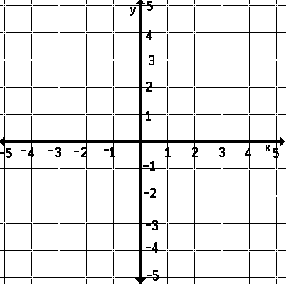 

3.  4. 

 