**AP STAT: Ch. 6 Normal Model and Standardizing**

* 1. You are in a history class and a math class. You take your chapter 1 test in both classes on the same day, and get them both back a few days later. Your grades are as follows. Which class did you do better in?

*History: 81% Math: 75%*

* 1. Same scenario. However, each teacher tells you a bit about how your class did. Which class did you do better in?

*mean: 76% mean: 70%*

Same in each – 5% above average

* 1. Same scenario. However how your teacher gives you the class standard deviations. Which class did you do better in?

*std. dev: 8% std. dev: 2.5%*

You were higher above average in your math class!

**Standardizing Observations**

So how can we compare one observation to another observation if they don’t have the same ***parameters*** (mean and std. dev)?

**Called: STANDARDIZING** sample mean population mean

* Called a Z-score  

sample std. dev population std. dev

* Z- score tells us… how many standard deviations an observation is above or below the mean
* Cancels out … all units and gives us an idea how common the value is or how unlikely it is
* Standardizing … makes the mean = 0 and makes the standard deviation = 1
* Generally … if , it is an unlikely value

**Example:** The heights of 18-24 year old women have a mean of 64.5” and a standard deviation of 2.5.”

We know a woman who is 69” tall. How does she compare to the rest of the women in her age group? Calculate her z score, and interpret what it means.

 The woman’s height is 1.8 standard deviations above the average height of women her age.

**Example:** We also know a man who is 71” tall. Who is taller relatively? Men are known to be distributed with a mean of 67” and a std. deviation of 2.3 inches.

 The woman is slightly taller relateively.

**Example:**  In a distribution of heights in a school the mean is 66” with a standard deviation of 2.8” Which is more unusual, a student with height of 63” or 73”?

 

The 73 inch tall student’s height is more unlikely because the absolute value of his z-score is greater. His height is further from the mean.

**Example:** To be certain that you would be accepted to the college you want, you would need an SAT score of at least 1900. However you took the ACT. What score would you need to get?

* For SAT mean = 1500 and std dev. = 250

* For ACT mean = 20.8 and std dev. = 4.8

SAT: ACT:

 

**THE NORMAL MODEL**

* Many sets of data … have a special shape that we call NORMAL

* symmetric & unimodal

* “bell shaped”

* Examples: test scores, heights, weights, etc.
* We MODEL this data … with a Normal Model (or curve)
* It is a … theoretical model, not meant to fit the data exactly (real world data)
* Example:

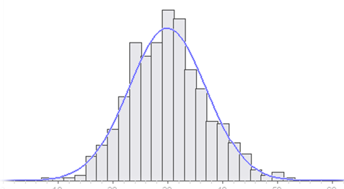

* It is based on … parameters, not summary statistics of a sample
* Uses … mean and standard deviation (because it is symmetric)

STATISTICS (samples) PARAMETERS (populations)

Mean  

Std. deviation  

Graphs boxplots, histograms, etc. smooth curve

NOTATION: 

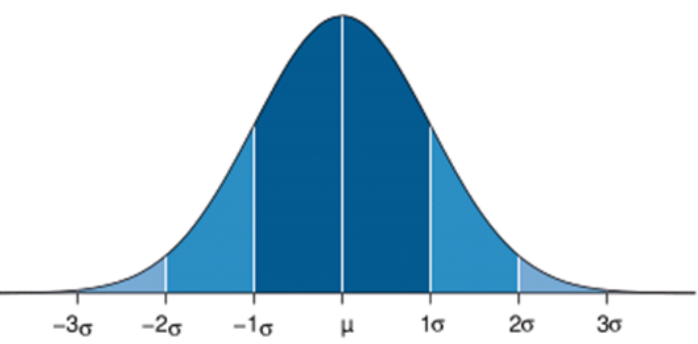

**Empirical Rule**

In a normal distribution with N(μ, σ)….

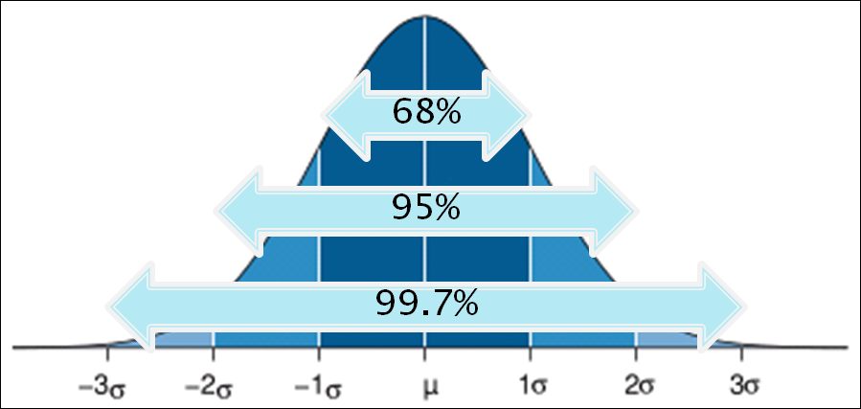

* + _68___% of the observations fall within ___________
  + _95___% of the observations fall within __________
  + _99.7_% of the observations fall within __________

**Example:** Suppose scores on an IQ test can be modeled normally with a mean of 100 pts. and a standard deviation of 16 pts.

* 1. Draw & label the normal model

N(100,16)



148

132

116

52

84

68

100

* 1. What percent of people scored over 123?

P(X>123)= 0.0753 = 7.53%

CALCULATOR:

2nd- DISTR

normalcdf(lower bound, upper bound, mean, standard deviation)

* + - * Use EE99 for inifinity & -EE99 for negative infinity
  1. What percent of people scored under 94?

P(x<43)= 0.3538 = 35.38%

* 1. What percent of people scored between 90 and 110?

P(90 < X < 110)= 0.4680 = 46.80%

* 1. What is the chance that someone scores over 120?

P(X > 120) = 0.1056 = 10.56%

* 1. What is the chance that someone scores less than 80?

P(X < 80)= 0.1056 = 10.56%

**EXAMPLE:** Blood pressures of high school students are N(170, 30).

1. Sketch the normal curve



80

170

140

260

230

200

110

1. What is the probability that a randomly selected high school student has a blood pressure of 180 or above?

P(X > 180) = 0.3694 = 36.94%

1. What is the probability that a high school student has a blood pressure between 160 and 230?

P(160 < X < 230) = 0.6078 = 60.78%

1. What blood pressure has 25% of the observations below it?

P(X < A) = 0.25

A = 149.765

CALCULATOR:

2nd – DISTR

invNorm( percent below - as a decimal, mean, standard deviation)

1. What blood pressure has 60% of the data above it?

P(X < A) = 0.40

A = 162.400

1. What is the IQR of the blood pressures?

P(X < Q3) = 0.75

Q3 = 190.235

P(X < Q1) = 0.25 IQR = 190.235 – 149.765 = 40.47

Q1 = 149.765

**WORKSHEET 6A**

1. **Suppose the average (mean) price of gas in a large city is $1.80 per gallon with a standard deviation of $0.05.**
2. Convert $1.90 and $1.65 to *z*-scores.
3. Convert the following *z*-scores back into actual values: 1.80 and –1.60.
4. **Suppose the attendance at movie theater averages 780 with a standard deviation of 40.**
5. An attendance of 835 equals a *z*-score of:
6. A *z*-score of –2.15 corresponds to an attendance of:
7. **A packing machine is set to fill a cardboard box with a mean of 16.1 ounces of cereal. Suppose the amounts per box form a normal distribution with a standard deviation equal to 0.04 ounce.**
8. What percentage of the boxes will end up with at least 1 pound of cereal?
9. Ten percent of the boxes will contain less than what number of ounces?
10. Eighty percent of the boxes will contain more than what number of ounces?
11. The middle 90% of the boxes will be between what two weights?
12. **The life expectancy of wood bats is normally distributed with a mean of 60 days and a standard deviation of 17 days.**
13. What is the probability that a randomly chosen bat will last at least 60 days?
14. What percentage of bats will last between 40 and 80 days?
15. What is the probability that a bat will break during the first month?
16. **Given a normal distribution with a standard deviation of 15, find μ if 15% of the values fall above 80.**
17. **Given a normal distribution with a mean of 25, what is the standard deviation if 18% of the values are above 29?**

**WORKSHEET 6B**

1. **The life expectancy of a particular brand of light bulb is normally distributed with a mean of 1500 hours and a standard deviation of 75 hours.**
2. What is the probability that a light bulb will last less than 1410 hours?
3. What is the probability that a light bulb will last more than 1550 hours?
4. What is the probability that a light bulb will last between 1563 and 1648 hours?
5. 15% of the time a light bulb will last more than how many hours?
6. **A water fountain is designed to dispense a volume of 12.2 oz. with a standard deviation of 0.5 oz.**
7. What percentage of cups end up with at least 12 oz.?
8. 75% of the cups contain more than how much water?
9. Find the IQR for the amount of water dispensed.
10. Find the 90th percentile for the amount of water dispensed.
11. **Given a normal distribution with a standard deviation of 10, what is the mean (μ) if 21% of the values are below 50?**
12. **Given a normal distribution with 80% of the values above 125 and 90% of the values above 110, what are the mean and standard deviation?**