Name: ______________________________________________
Ecology and Evolution Keystone Short Answer Practice

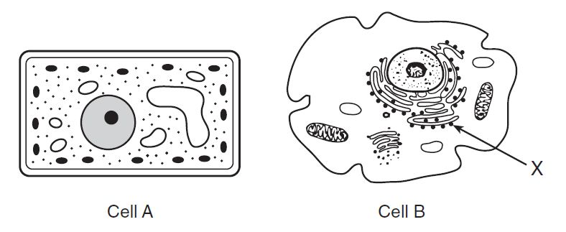
- Identify the organelle labeled X in cell B. Explain what its function is for the cell.

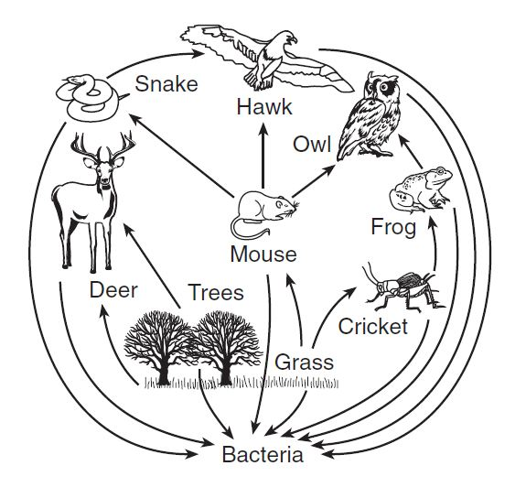

State what would most likely happen to the cricket population if all of the grasses were removed.

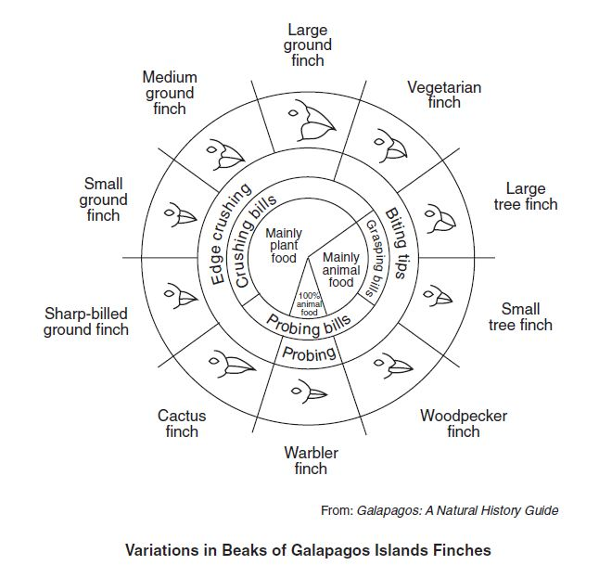
- The cactus finch, warbler finch, and woodpecker finch all live on one island. Based on the information in the diagram below, which one of these finches is least likely to compete with the other two for food? Support your answer with an explanation.
____________________________________________________________________________________________________________________________________________________________________________________________________________________________________________________________________________________________________________________________________________________________________________________________________________________________________
- Base your answers on the information below and on your knowledge of biology.
Due to the negative effects on the environment of burning coal and oil, society is looking for resources that are renewable.
Identify one renewable resource that can be used to generate energy.

State one benefit, other than the fact that it is renewable, of using this resource. _____________________________________________________________________________________
_____________________________________________________________________________________
- A student, using a metric ruler, measured a larva as represented in the diagram below.
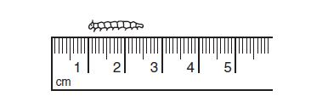
What is the length of the larva, in millimeters? __________________________

- Base your answers on the information below and on your knowledge of biology.
A student states that exercise will affect the number of times a person can squeeze a clothespin in a certain amount of time. An experiment is carried out to test this hypothesis. One group of ten students sits quietly before squeezing a clothespin as many times as possible during a one-minute interval. A second group of ten students does 25 jumping jacks before squeezing a clothespin as many times as possible during a one-minute interval.
State one way the experiment could be improved in order to increase the validity of the results. [1]
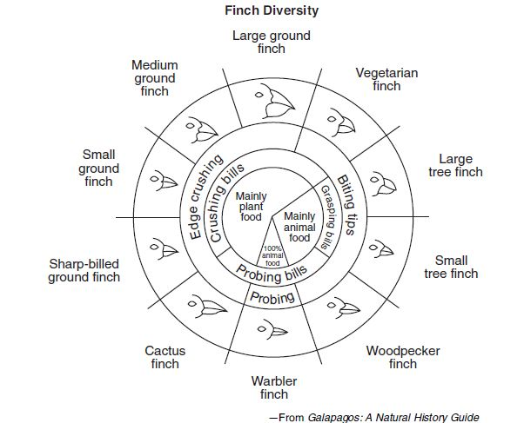
Small ground finches and medium ground finches live on an island with abundant plant and animal food. Predict how the small ground finch and the medium ground finch would be affected if warbler finches migrated to the island where these finches live. Support your answer.

____________________________________________________________________________________________________________________________________________________________________

