**Unami Middle School**

**2022-2023**

**School Supplies**

Successful students are equipped with supplies from the first day and throughout the year. Below is a list of materials you need for both school and home.

* A different color **folder** for each subject area
* **pencil case**
* **Earbuds** (pc compatible & microphone)
* **ELA Composition Notebook**
* 1 **3 subject notebook**
* 1 pack of **post-it-notes**
* 2 packs of **colored pencils** (one for home and one for school)
* 1 small pocket **pencil sharpener**
* 1 pack of **pencils** and 1 pack of **pens** (blue/black)
* Scientific **calculator** (TI 30 preferred) – NOT a graphing calculator
* **Highlighters**
* **Independent Reading Book**

*Optional Items for Donation:*

* 2 boxes of **tissues** to be given to Resource teacher

**On our first day, you can expect to . . .**

* Get to know your teachers and teammates
* Navigate the school
* Attend your “A” day classes and find your Encore/Resource classrooms
* Learn the cafeteria rules and routines
* Open your locker
* Discover more about your new middle school team!

**. . . all with the help of your teachers.**

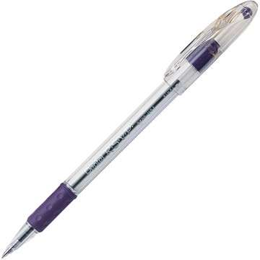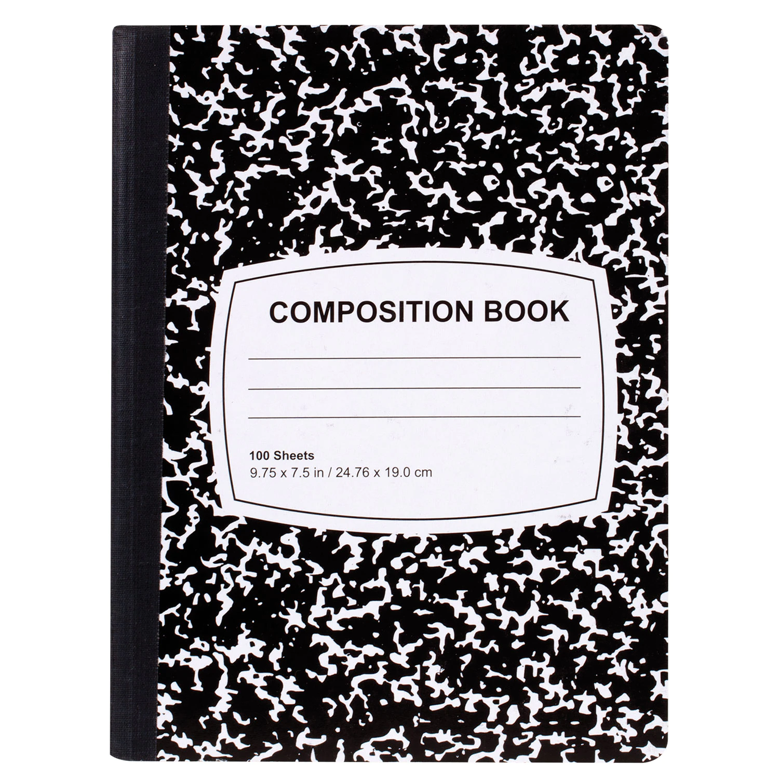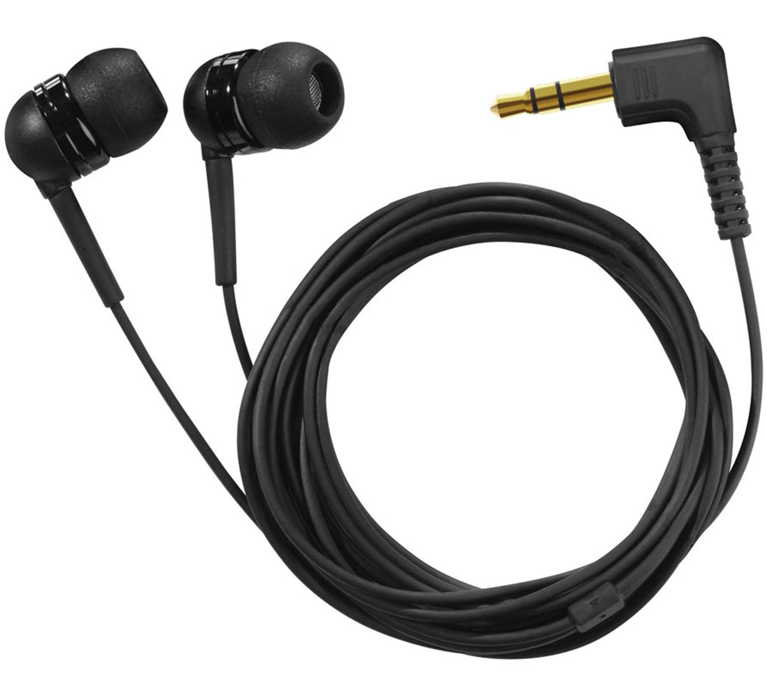



**Get curious!**

**Get involved!**

Check out the Unami website for the various ways you can grow as a member of the school community.

**Stay Connected**

**Unami’s Website**

https://www.cbsd.org/unamims

**Twitter**

@CBUnamiMS

#unamirocks #southside #cbsd

**Parent Portal**

https://campus.cbsd.org/campus/portal/cbsd.jsp

**Canvas**

https://www.cbsd.org/canvas

**What is Team?**

Unami’s 7th Grade is organized into two teaching teams--**Spark & Ignite**

**Your Team** is your “home base,” more than just a location of teachers and classrooms.

Your teachers meet to plan team activities, coordinate lessons and due dates, discuss student progress, and how to **ignite & spark** your learning. Your teaching team looks out for you!

**Unami Middle School 2022-2023**

Your team teachers have been busy planning for the school year. We are eager to meet you and look forward to an exciting year together!

The 7th grade class’s theme this year is embracing the many catalyst moments in your school year through **problem-solving** and **advocacy**. As a member of the 7th grade class, you will have many learning opportunities to problem-solve, advocate for yourself, and celebrate your successes. In this first year of middle school, you will grow as a student and young adult, meeting new friends and creating many fun memories.

**Welcome to 7th Grade**