Guiding Questions Name: _________________
Stave V: The End of It
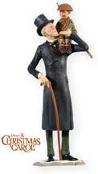

1. What does it mean when Scrooge exclaims that he will, “Live in the Past, the Present,
and the Future!”?

2. What are three similes that Scrooge compares himself to in the beginning of Stave 5?

3. How long did it take the Spirits to have Scrooge witness his past, present and the future?

4. Where is Scrooge sending this turkey and do the recipients know who is giving it to them?

5. Name all of the different ways that Scrooge is proving that he is a changed man.

6. Where did Scrooge spend Christmas Day?

7. How does Scrooge trick Bob Cratchit the day after Christmas?

8. Did the spirits ever visit Scrooge again?

