Station 1: Nixon's Dilemma- Achieving "Peace with Honor"
President Nixon entered the White House with a mandate to change the course of the Vietnam War. To that end, he relied heavily on his national security adviser, Henry Kissinger. Nixon and Kissinger drew two basic conclusions about Vietnam. First, they agreed that the war was not winnable, at least in the conventional sense. U.S. forces could not fight their way into Hanoi the way the Allies had entered Berlin in World War II. The political costs, and the cost in American lives, would be too great. Second, they decided that the United States could not just “cut and run.” An abrupt withdrawal from Vietnam would damage U.S. credibility by showing both friends and foes that the United States could not be trusted to stand by its allies.
Instead, Nixon sought to achieve “peace with honor.” He wanted to end the war in a way that left the reputation of the United States intact. Nixon decided on a carrot-and-stick approach—a tactic that combines actions that reward (the “carrot”) with actions that punish (the “stick”). Using this approach, he hoped to persuade the North Vietnamese to accept a negotiated end to the war.
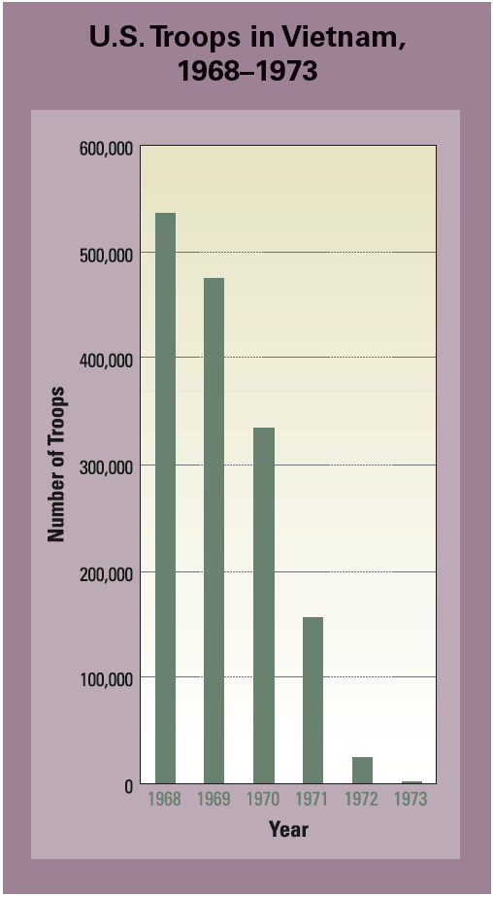

Station 2: Vietnamization
When diplomacy failed to bring about “peace with honor,” Nixon decided to try another approach known as Vietnamization. South Vietnam, he said, would gradually take over conduct of the war, while American GIs would steadily be withdrawn. In this way, Nixon could offer the “carrot” of troop reductions to North Vietnam, while easing antiwar tensions at home.
Vietnamization was part of a broader Asian policy that called for each American ally to accept primary responsibility for providing soldiers for its own defense. The number of U.S. troops in Vietnam peaked in March 1969 at 543,000. By the end of the year, more than 60,000 of those soldiers would be withdrawn.
The plan for Vietnamization set three main goals for South Vietnam: self-government, self-development, and self-defense. According to this plan, political reforms, including local elections, would increase popular participation in government and provide for essential public services. Rural development would bring economic opportunity to the countryside, while pacification would create local self-defense forces to take charge of village security.
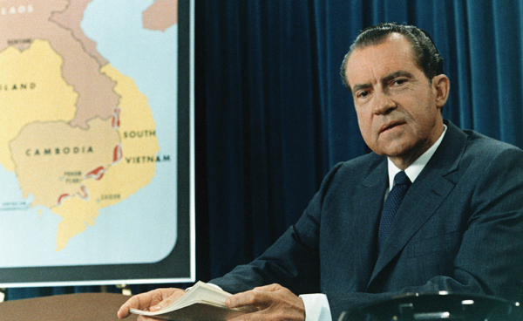
U.S. officials believed that strengthening South Vietnam’s military forces was key to making Vietnamization work. Training schools were expanded. Pay for soldiers in South Vietnam’s army (ARVN) was increased. Living conditions in military camps were improved. So many U.S. ships, planes, helicopters, and vehicles were shipped to Vietnam that one Congressman wondered whether the goal of Vietnamization was to “put every South Vietnamese soldier behind the wheel.”

Station 3: Widening the Air War and Invading Cambodia
Peace negotiations in Paris were proving fruitless. The offers by the United States—U.S. troop withdrawals and an end to bombing—did not satisfy the North Vietnamese.
Nixon considered several military options to pressure North Vietnam to negotiate, including bombing its industrial areas, mining its harbors, and invading its territory. His strategy, which he called the “madman theory,” was to make North Vietnam’s leaders and their allies, the Soviet Union and China, believe that he would do anything to win the war. He even briefly put nuclear forces on alert as a bluff that he might use tactical nuclear weapons, small but highly destructive nuclear bombs.
Nixon had already shown a willingness to expand the war. In March 1969, he had secretly ordered B-52s to begin bombing Cambodia, a neutral nation on Vietnam’s western border. For the next four years, U.S. bombers would strike communist base camps and supply lines in Cambodia.
With Vietnamization, U.S. ground forces began focusing more on intercepting supplies from the north and less on fighting guerrillas in the south. Nixon also decided to give those ground forces another mission. In April 1970, he ordered U.S. troops to invade Cambodia. The invasion was a partial success. The GIs destroyed enemy bases and relieved pressure on ARVN forces fighting in the south. But the invasion did not help the peace process. The communists boycotted the Paris talks until U.S. troops left Cambodia three months later.
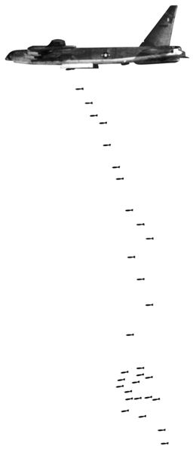
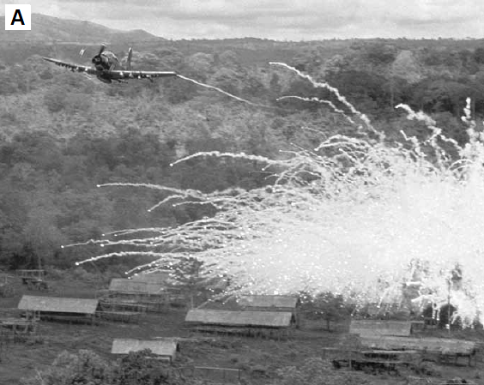

Station 4: My Lai Massacre
On November 12, 1969, journalist Seymour Hersh published an article describing a grisly killing spree at My Lai, a village in South Vietnam. The My Lai Massacre had taken place in March 1968 but had been covered up by the military. U.S. soldiers, believing My Lai to be a Viet Cong stronghold, had gone there on a search-and-destroy mission. To their surprise, they found no armed Viet Cong in the village, just women, children, and old men. Nevertheless, one morning the soldiers rounded up and executed about 500 of these civilians. Only a handful of villagers survived.
News of the massacre shocked Americans, though many doubted that such an atrocity could occur. Others believed the soldiers were just following orders or that their actions were justified. Enough Americans expressed outrage, though, that Nixon decided to accelerate the withdrawal of troops from Vietnam.
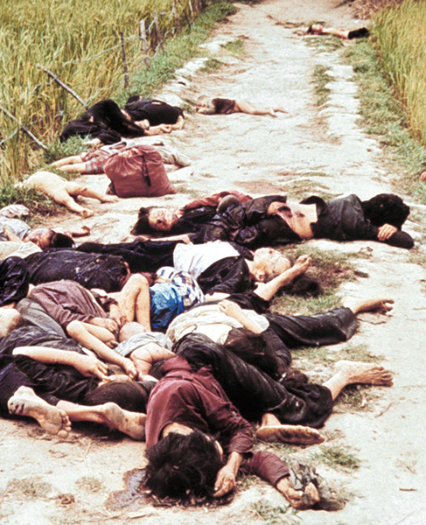

Station 5: Kent State Shooting
The invasion of Cambodia in 1970, brought another upsurge in protests. Students held mass rallies and demonstrations, some of which turned violent. The Kent State shootings were the most shocking example. On May 4, students at Kent State University in Ohio were holding a peace rally after several days of violent unrest, which included the burning of the army’s Reserve Officers’ Training Corps (ROTC) building on campus. National Guard troops, called out to quell the protests, ordered the crowd to disperse. After some students began chanting slogans and throwing rocks, the troops opened fire. Four students were killed and nine were wounded.
Ten days later, a similar incident took place at Jackson State College in Mississippi. Protesters threw debris at police, and the officers responded with shotgun and machine-gun fire that left two students dead.
Reactions to these incidents varied. Many Americans were stunned, and protests erupted on college campuses and in cities across the nation. Vietnam veterans took part in some of these protests, as did several labor unions. Nevertheless, only a small percentage of Americans ever demonstrated publicly. In fact, many Americans rejected antiwar protests, seeing them as unpatriotic and disruptive. In May 1970, construction workers in New York City showed their disgust with antiwar demonstrators by holding marches in support of the war. Some soldiers also wrote home asking for public support. An army nurse wrote her parents, saying, “Display the flag, Mom and Dad . . . And tell your friends to do the same. It means so much to us to know we’re supported, to know not everyone feels we’re making a mistake being here.”
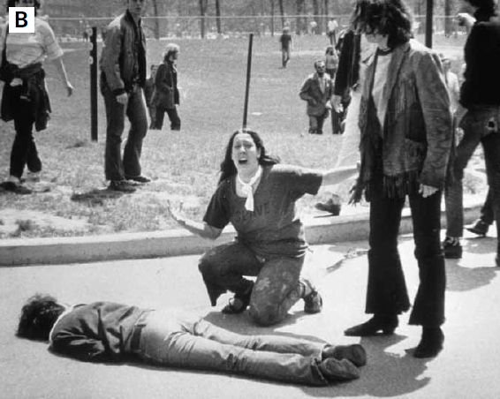

Station 6: Veterans and Prisoners of War Return Home

By March 29, 1973, the United States had withdrawn all combat forces from Vietnam. Arriving home, many soldiers were dismayed to find themselves the victims of their country’s bitter debate over the war. Unlike soldiers returning from World War II, most Vietnam veterans were not treated like heroes. Few communities welcomed their soldiers back with parades or celebrations. Instead, Vietnam veterans were often shunned or simply ignored by the general public. As a result, they did not receive the support and understanding they deserved for their service and sacrifices.
For combat veterans especially, the Vietnam War had been a harrowing experience. Many soldiers were haunted by their fears in battle and by the death and destruction they had witnessed. They rarely talked about their combat experiences, except with other veterans. Of the 2.6 million Americans who served in Vietnam, nearly a half million suffered from post-traumatic stress disorder. Symptoms of this mental illness include anxiety, irritability, nightmares, and depression.
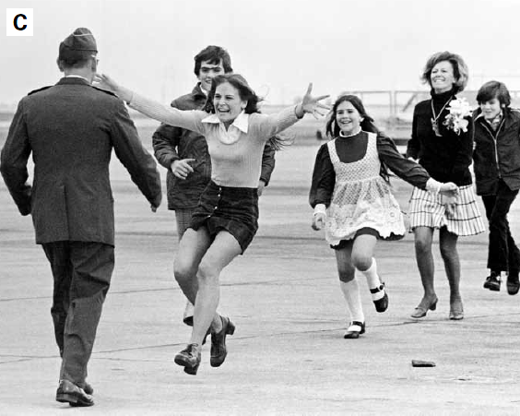
More than 760 Americans were taken prisoner by the North Vietnamese. Of these prisoners of war, or POWs, at least 110 died in captivity. The typical POW was a pilot whose plane had been shot down. POWs lived in miserable conditions, often in solitary confinement, and they faced regular interrogations and torture.
Station 7: South Vietnam’s fall to Communism
On April 29, 1975, all American personnel were ordered to leave South Vietnam immediately. U.S. combat troops had pulled out two years before, and since then the South Vietnamese army had lost ground to the North Vietnamese. By mid-April, most of South Vietnam had fallen to the communists, and the enemy was bearing down on Saigon.
The scene in Saigon that day was chaotic. The streets were filled with South Vietnamese trying to flee the invading communist army. Some climbed into small boats and headed out to sea, hoping to board U.S. ships. Others flocked to the U.S. embassy in the hope of getting a place on one of the helicopters ferrying American personnel to safety.
Several thousand Vietnamese were allowed to evacuate that day, but most were turned away for lack of space. Even for those who did manage to get out, the experience was often traumatic.
President Nixon had hoped to arrange a peaceful end to the Vietnam War that would leave South Vietnam free and independent. However, the United States failed to achieve that goal.
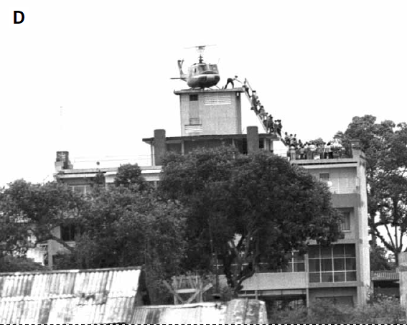

Station: Congress Responds to a Widening War
After the invasion of Cambodia, antiwar members of Congress intensified their efforts. By the end of 1970, they had repealed the Gulf of Tonkin Resolution, which had allowed Johnson and Nixon to escalate the conflict without a formal declaration of war. In February 1971, Congress passed legislation forbidding U.S. troops from operating outside the borders of South Vietnam.
Two years later, when Congress learned that Nixon had secretly bombed Cambodia without congressional approval, it passed the War Powers Resolution. This law placed strict limits on a president’s power to use the armed forces in hostilities without congressional authorization. By then, support in Congress for the war had greatly declined.

