**Welcome to 9th Grade English**

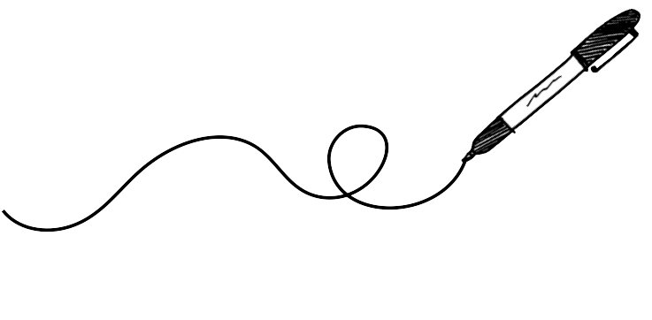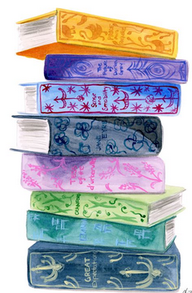STThomas@cbsd.org – (267) 893-2800 ex. 6415

**Core Assessments**

* During the third and fourth marking periods, students will complete   
  two core assessments.
  + **Personal Narrative**: Students will choose one moment in their lives that had an impact on them and write a creative narrative while making use of dialogue, figures of speech, and imagery.
  + **Character Dialogue/Monologue Core**: Students will work in pairs to create a script between a historical figure and a character from the literature we have read throughout the year discussing a common theme.  
    There will be a monologue option for students as well.

**Grading**

The grade from the class will come 100% from summative assessments. Formative assessments will be tracked in Parent Portal so you can see the work your child is completing to prepare for their summative assessments, but no grade will be attached.

Upon student request, Second Chance Learning may be offered   
on major assignments for up to 100%

**Core Writing**

* The focus of writing in ninth grade is experimenting with narrative, analytical, and thematic writing. Students will also write poetry.
* Students will be writing extensively in preparation for the core writing pieces. Journal writing will be a regular part of the language arts class so that students may respond to reading selections and class discussions, as well as record and elaborate upon their own thoughts and feelings. The language arts class also helps to develop writing techniques that will be used in other content areas, including research skills.

**Core Reading**

* Required Works
  + *Romeo and Juliet* (William Shakespeare)
  + *To Kill a Mockingbird* (Harper Lee)

*\** Students will read *at least* one other novel or play.

* Other Possible Selections
* \**The Chosen* (Chaim Potok)
* \**The Book Thief* (Markus Zusak)
* \**Lord of the Flies* (William Golding)
* \**A Separate Peace* (John Knowles)
* *\*The Illustrated Man* (Ray Bradbury)
* *Inherit the Wind* (Jerome Lawrence/ Robert E. Lee)
* *Maus I and Maus II* (Art Spiegelman)
* *That Was Then, This is Now* (S.E. Hinton)
* *Touching Spirit Bear* (Ben Mikaelsen)
* *The Fault in Our Stars* (John Green)
* *The Hunger Games* (Suzanne Collins)
* *The Adventures of Tom Sawyer* (Mark Twain)
* *The Wave* (Todd Strasser)
* *The Boy in the Striped Pajamas* (John Boyne)
* *No Promises in the Wind* (Irene Hunt)

* Denotes a more challenging text  
 selection for Honors courses.



**Statement for Academic Dishonesty**

Academic honesty is expected in this class.  Cheating in any form is unacceptable behavior.  Cheating is cause for a student to lose membership/eligibility in the Honor Society.  Students found to be cheating on tests, quizzes, projects, or copying homework, or any written work will receive consequences as deemed appropriate to the incident.  Plagiarism of any type (including electronic) is considered cheating.  Teachers will notify parents of the incident.  When plagiarism is suspected, the teacher and the student will develop a plan for the assignment to be redone.  Additionally, student may receive a non-academic consequence.  (CBSD Student Handbook)

