Vietnam War 101

https://www.thoughtco.com/vietnam-war-101-2361349
by Kennedy Hickman
Military and naval history expert Kennedy Hickman has nearly 20 years of experience as a museum curator and director, and has been featured on The History Channel.
Updated March 17, 2017

An Overview of the Conflict
Bottom of Form
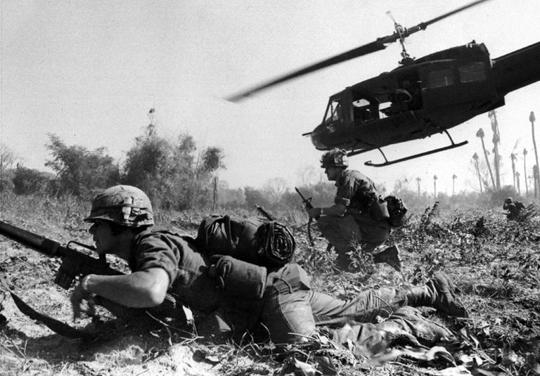
Combat operations at Ia Drang Valley, Vietnam, November 1965. Bruce P. Crandall's UH-1 Huey dispatches infantry while under fire. Photograph Courtesy of the US Army
The Vietnam War occurred in present-day Vietnam, Southeast Asia. It represented a successful attempt on the part of the Democratic Republic of Vietnam (North Vietnam, DRV) and the National Front for the Liberation of Vietnam (Viet Cong) to unite and impose a communist system over the entire nation. Opposing the DRV was the Republic of Vietnam (South Vietnam, RVN), backed by the United States. The war in Vietnam occurred during the Cold War, and is generally viewed as an indirect conflict between the United States and Soviet Union, with each nation and its allies supporting one side.

Vietnam War - Causes of the Conflict
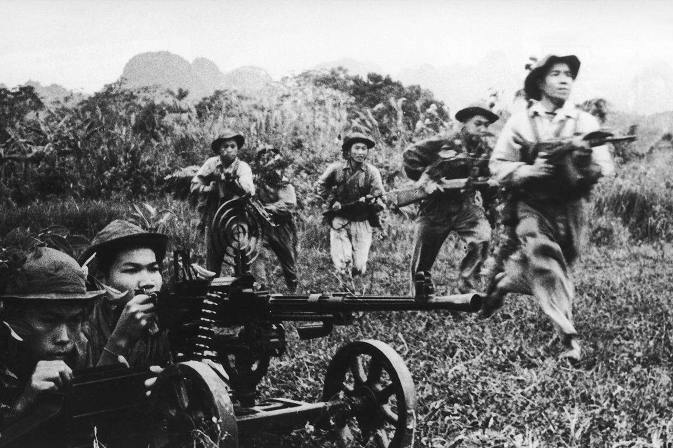
Viet Cong forces attack. Three Lions - Stringer/Hulton Archive/Getty Images
With the French defeat at Dien Bien Phu and end of the First Indochina War in 1954, Vietnam was partitioned through the signing of the Geneva Accords. Split in two, with a communist government in the north under Ho Chi Minh and a democratic government in the south under Ngo Dinh Diem the two Vietnams maintained an uneasy coexistence for five years. In 1959, Ho launched a guerrilla campaign in South Vietnam, led by Viet Cong (National Liberation Front) units, with the goal of uniting the country under communist rule. These guerilla units found support among the rural population who desired land reform.
Concerned about the situation, the Kennedy Administration increased aid to South Vietnam. As part of a larger policy of containing the spread of communism, the United States worked to train the Army of the Republic of Vietnam (ARVN) and provided military advisors to help combat the guerrillas. Though the flow of aid increased, President John F. Kennedy was against the use of ground forces in Southeast Asia believing their presence would cause adverse political consequences.

Vietnam War - Americanization of the War
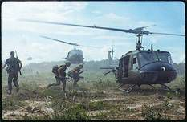
The UH-1 Huey - An Icon of the Vietnam War. Photograph Courtesy of the National Archives & Records Administration
In August 1964, a US warship was attacked by North Vietnamese torpedo boats in the Gulf of Tonkin. Following this attack, Congress passed the Southeast Asia Resolution which allowed President Lyndon Johnson to conduct military operations in the region without a declaration of war. On March 2, 1965, US aircraft began bombing targets in Vietnam and the first troops arrived.
Moving forward under Operations Rolling Thunder and Arc Light, American aircraft commenced the systematic bombing of North Vietnamese industrial sites, infrastructure, and air defenses. On the ground, US troops, commanded by General William Westmoreland, won victories over Viet Cong and North Vietnamese forces around Chu Lai and in the Ia Drang Valley that year.

Vietnam War - The Tet Offensive
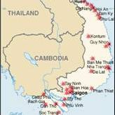
A map depicting those areas attacked by North Vietnamese and Viet Cong forces during the Tet Offensive. Map Courtesy of the Central Intelligence Agency
Following these defeats, the North Vietnamese avoided fighting conventional battles and focused on engaging US troops in small unit actions in the sweltering jungles of South Vietnam. As fighting continued, leaders Hanoi vigorously debated how to move forward as American bombing was beginning to cripple their economy. Resolving to resume more conventional operations, planning commenced for a large-scale operation. In January 1968, the North Vietnamese and the Viet Cong launched the massive Tet Offensive.
Beginning with an assault on US Marines at Khe Sanh, the offensive included attacks by the Viet Cong on cities throughout South Vietnam. Fighting raged across the country and saw ARVN forces hold their ground. Over the next two months, American and ARVN troops, successfully turned back the Viet Cong assault, with especially heavy fighting in the cities of Hue and Saigon. Though the North Vietnamese were defeated with heavy casualties, Tet shook the confidence of the American people and media who had thought the war was going well.

Vietnam War - Vietnamization
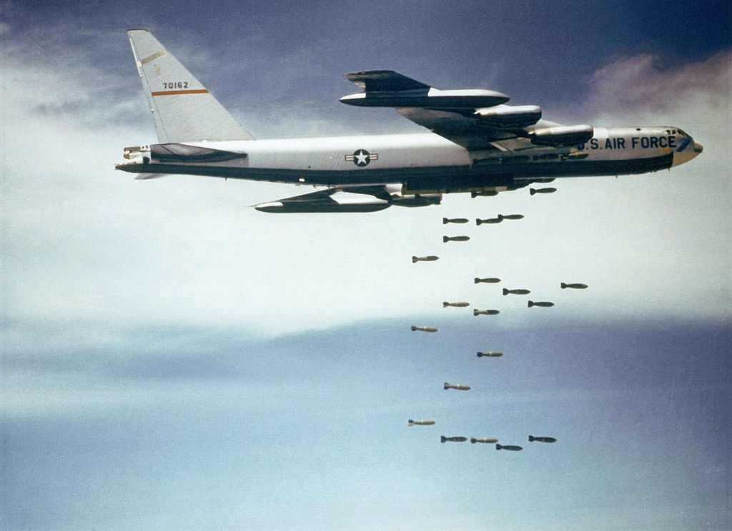
B-52s strike Vietnam. Photograph Courtesy of the US Air Force
As a result of Tet, President Lyndon Johnson opted not to run for reelection and was succeeded by Richard Nixon. Nixon's plan for ending US involvement was to build up the ARVN so that they could fight the war themselves. As this process of “Vietnamization” began, US troops started to return home. The mistrust of the government that had begun after Tet worsened with the release of news about bloody engagements of questionable value such as Hamburger Hill (1969). Protests against the war and American policy in Southeast Asia further intensified with events such as soldiers massacring civilians at My Lai (1969), the invasion of Cambodia (1970), and the leaking of the Pentagon Papers (1971).

Vietnam War - The End of the War & the Fall of Saigon
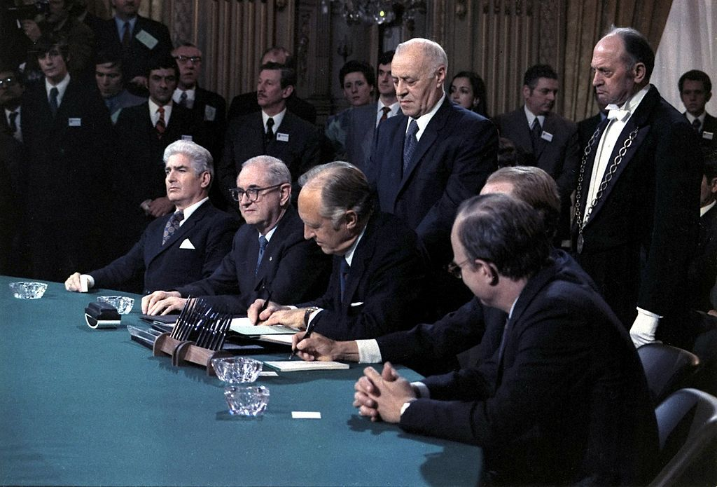
Signing of the Paris Peace Accords, 1/27/1973. Photograph Courtesy of the National Archives & Records Administration
The withdrawal of US troops continued and more responsibility was passed to the ARVN, which continued to prove ineffective in combat, often relying on American support to stave off defeat. On January 27, 1974, a peace accord was signed in Paris ending the conflict. By March of that year, American combat troops had left the country. After a brief period of peace, North Vietnam recommenced hostilities in late 1974. Pushing through ARVN forces with ease, they captured Saigon on April 30, 1975, forcing South Vietnam’s surrender and reuniting the country.
Casualties:
United States: 58,119 killed, 153,303 wounded, 1,948 missing in action
South Vietnam 230,000 killed and 1,169,763 wounded (estimated)
North Vietnam 1,100,000 killed in action (estimated) and an unknown number of wounded

Hickman, Kennedy. "Vietnam War 101." ThoughtCo, Oct. 22, 2018, thoughtco.com/vietnam-war-101-2361349.

