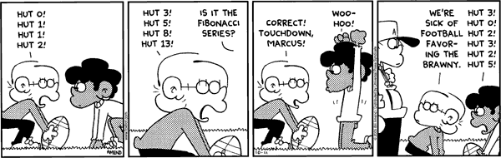
Unit Project : Fibonacci Numbers & The Golden Ratio

Step One:
The following is the start of the Fibonacci series
0, 1, 1, 2, 3, 5, 8, 13, 21, 34, 55, …

- What is the pattern in the Fibonacci series?

- Continue the Fibonacci series up to 1,346,269. Feel free to type your list or write it on a separate sheet of paper.

Step Two:
The Fibonacci numbers are a pattern. However, there are patterns within the pattern of the Fibonacci series.

- Find and explain one such pattern.

Ex. Multiples of 5: When starting at 5 in the Fibonacci sequence, all multiples of 5 are every 5th Fibonacci number.

0,1,1,2,3,5,8,13,21,34,55,
so… every 5th Fibonacci number is a multiple of 5

