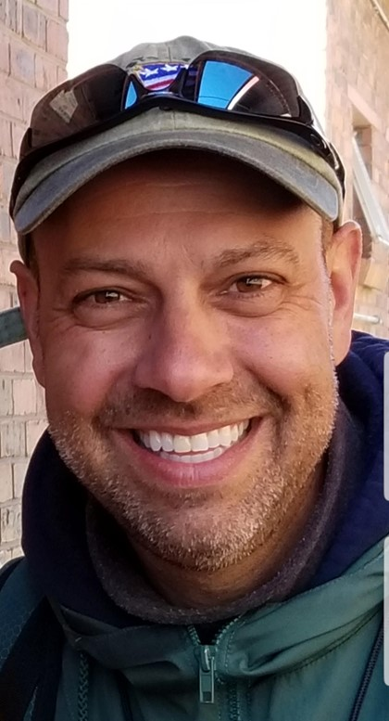
Welcome to Mr. Cerauli’s
Fourth Grade Class
Room 207

Dear 4th Graders and Parents,

Welcome to 4th grade at Jamison Elementary School! I am looking forward to an exciting, busy, and fun-filled school year. It is hard to believe that summer is ½ over and another school year is quickly approaching! I will soon be busy getting our classroom ready.

At the end of my letter, I am attaching a copy of the Room 207 classroom supplies that are needed in addition to the list that was already sent home at the end of last year. If you have misplaced that list, there is a copy of the 4th grade general supply list included in this letter! Please be sure to write your NAME on everything!

Each morning we will have a short snack break. Please bring a healthy snack with you on the first day of school!

The first week of school will be spent getting to know one another, setting goals and expectations, playing some games, and creating our classroom community. For the first day of school, please bring with you a small object or a picture which represents something memorable from your summer. An example might be a beach ball or a photo from a family vacation. There will be an opportunity to share these items with the class and explain how it relates to a favorite summer memory.

Every year I give a “before school” homework assignment. This year, we will be studying Pennsylvania! Here is a chance for you to test your knowledge of important Pennsylvania facts! Feel free to use references to help locate the correct answers. This project will be collected at Jamison’s meet and greet or on the first day of school if you cannot attend. Jamison’s meet and greet is Thursday, August 25th 2:30-4:00pm. ☺

Back to school night… Thursday, September 6, 2021, for 4th grade (6:00-6:40p.m.)

(Continue next page…)
I hope you continue to enjoy the remainder of the summer and that you come to school ready to work hard, learn a lot, and have FUN!

See you soon,
Mr.Cerauli

*If you would like to write to me, my E-Mail address is fcerauli@cbsd.org

General Supply List for 4th grade
  - 2 Ultra Fine Tip Sharpie Markers- (black)
  - Colored Pencils—6-12 pack
  - Whiteboard markers-3-4
  - Whiteboard eraser or old sock
  - 2 Folders (1-Music and 1- library)
  - 3 Black and White Marble Composition Notebooks-
(Please make sure that pages are securely sewn (not glued) into the notebook.
  - 1 pair of INEXPENSIVE earbuds/headphones!

Additional Supply List For Room 207
- 1 pack of post-its (Color of your choice!)
- 1 pack of 3X5 index cards (lined on one side) (WHITE please…)
- 1- Blue plastic/vinyl pocket folder (No trapper keeper styles)
*Staples has great plastic/vinyl pocket folders.
- 1 manual pencil sharpener with detachable shaving catcher. Not battery powered.
- Optional…
  - 1 bottle of anti-bacterial hand sanitizer (Dollar store is great for this!)
  - 1-2 tissue boxes!
  - 1-2 containers of “Wet Ones” antibacterial wipes. No Clorox please.

Thank you for getting these additional supplies. If you have difficulty getting any of these, please feel free to let me know!

Next page for your first 4th grade assignment!

Name: _____________________________________

Pennsylvania…
- Pennsylvania is the first state of the fifty United States to list their _________________________________ on a license plate.
- In 1909 the first baseball stadium was built in __________________________.
- Hershey is considered the ____________________________ Capital of the United States.
- In 1913 the first automobile service station opened in this city __________________________.
- In 1946 Philadelphia became home to the first _______________________________.
- The first daily newspaper was published in Philadelphia in the year _____________________.
- The Rockville Bridge in Harrisburg is the longest bridge made of _________________ in the world.
- The Declaration of Independence was signed in Philadelphia in the year ______________.
- The first commercial radio broadcast was broadcasted in the Pennsylvania city. ______________.
- Each year on Christmas day the "Crossing of the Delaware" is reenacted at ____________________ __________________.
- Pennsylvania is the only original colony not bordered by the _________________ ____________.
- Benjamin Franklin founded the _____________________ __________, the first public one in the United States.
- Pittsburgh is famous for manufacturing _________________.
- Little League Baseball's first World Series was held in 1946 in ____________________________.
15. Philadelphia was once the United States capital city. True False

Bonus Question: (We will be studying “energy” in 4th grade too!)

What is a renewable energy source that is used every day at your school?

Answer:

Please create a picture of you using this “power”.

