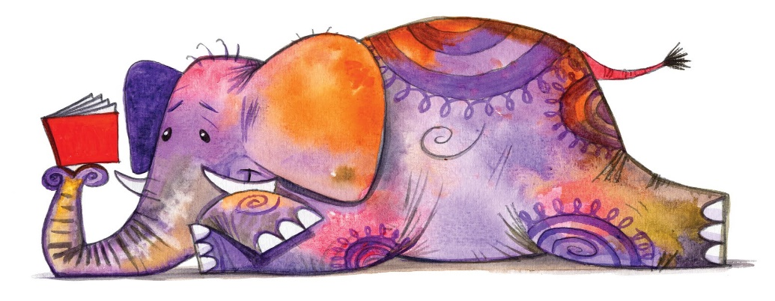

March 19th
- Overview - Reading and Writing
- Estimated Time - 10-15 minutes
- Explanation of Activity/ Assignment - Choose 1 book in your reading bag to read.
- Quick things to know - Find a quiet place to read to yourself, a pet, a family member or a friend.
- Tasks
  - Choose 1 book.
  - Read the book.
  - If you could ask the author a question about the book, what would it be? Write your question.
- Links - Feel free to use this paper for your writing.
- Writing Paper

