**Current Electricity**

**BIG IDEAS**

1. [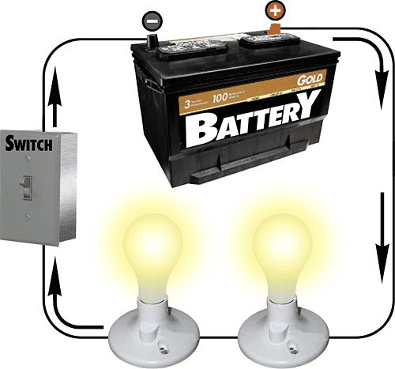](http://www.google.com/url?sa=i&rct=j&q=electrical+circuit+loop&source=images&cd=&cad=rja&docid=VbJUzah3WCjwIM&tbnid=ayaZVHsRXLjU2M:&ved=0CAUQjRw&url=http://www.pitsco.com/content/?art%3D34%26ap%3D6&ei=LrZyUoD9D82tkAeXvYDYAw&bvm=bv.55819444,d.eW0&psig=AFQjCNG6xQk4IC5J6-eKenBvaJxxxDqmKg&ust=1383335821399583)For an **electric current to flow**, it must form a complete **path (loop)** for it to follow around a circuit and return to its source.
2. The flow of **electric current** *can produce* **light, heat, sound, motion, or magnetic effects (magnetism)**.
3. **Conductor**- materialthat allows **electric current** to **flow easily**:

*Examples:*

* Metal
* Copper
* Aluminum
* Silver
* Water

1. **Insulator**- materialthat makes **electric current** **stop** or **slow down**.

*Examples:*

* plastic
* wood
* Styrofoam
* cardboard
* cloth
* clay
* rubber

1. It is important to avoid electrical hazards by using electricity safely.

**DANGERS** of electricity:

**Electrocution**- Electricity *flows through* a person and cause death.

**Fire**- *Too much electric current heats things up* and can cause fire.