**Memory Articles**

|  |
| --- |
| **The** **Three Memory Storage Systems**  In cognitive psychology, memory is usually divided into three stores: the sensory, the short-term, and the long-term. The progress of information through these stores is often referred to as: |

**The Information Processing Model**

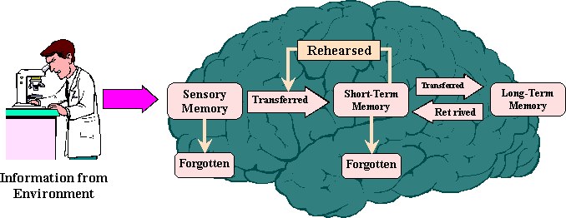

|  |  |  |
| --- | --- | --- |
| |  | | --- | | Donald Hebb argued that it was doubtful that a chemical process could occur fast enough to accommodate immediate memory, yet remain stable enough to accommodate permanent memory. Hence, the present theory of three storage areas. | | **Sensory Memory**  The sensory memory retains an exact copy of what is seen or heard (visual and auditory). It only lasts for a few seconds, while some theorize it last only 300 milliseconds. It has unlimited capacity.  [**Short-Term Memory**](http://www.skagitwatershed.org/~donclark/hrd/learning/memory.html#STM)**(STM)**  Selective attention determines what information moves from *sensory memory* to *short-term memory*. STM is most often stored as sounds, especially in recalling words, but may be stored as images.  Works like RAM memory in computers; provides a working space. Is thought to be 7 bits in length, that is, we normally only remember 7 items. STM is vulnerable to interruption or interference.  [**Long-Term Memory**](http://www.skagitwatershed.org/~donclark/hrd/learning/memory.html#LTM) **(LTM)**  This is relatively permanent storage. Information is stored on the basis of meaning and importance. |
| **Short-Term Memory (STM)**  STM is characterized by:   |  |  | | --- | --- | | http://www.skagitwatershed.org/~donclark/hrd/learning/atabbul1.gif | A limited capacity of up to seven pieces of independent information. | | http://www.skagitwatershed.org/~donclark/hrd/learning/atabbul1.gif | The brief duration of these items last from 3 to 20 seconds. | | http://www.skagitwatershed.org/~donclark/hrd/learning/atabbul1.gif | Decay appears to be the primary mechanism of memory loss. |   After entering sensory memory, a limited amount of information is transferred into short-term memory. Within STM, there are three basic operations:   |  |  | | --- | --- | | http://www.skagitwatershed.org/~donclark/hrd/learning/atabbul1.gif | **Iconic memory** - The ability to hold visual images. | | http://www.skagitwatershed.org/~donclark/hrd/learning/atabbul1.gif | **Acoustic memory** - The ability to hold sounds. Acoustic memory can be held longer than iconic memory. | | http://www.skagitwatershed.org/~donclark/hrd/learning/atabbul1.gif | **Working memory** - An active process to keep it until it is put to use (think of a phone number you'll repeat to yourself until you can dial it on the phone). Note that the goal is not really to move the information from STM to LTM, but merely put the information to immediate use. |   [**Mechanism of short-term memory loss revealed**](http://www.newscientist.com/news/news.jsp?id=ns99991658)  The process of transferring information from STM to LTM involves the encoding or consolidation of information. This is not a function of time, that is, the longer a memory stayed in STM, the more likely it was to be placed into LTM; but on organizing complex information in STM before it can be encoded into LTM. In this process of organization, the meaningfulness or emotional content of an item may play a greater role in its retention into LTM. As instructional designers, we must find ways to make learning **relevant** and **meaningful** enough for the learner to make the important transfer of information to long-term memory.  Also, on a more concrete level, the use of [chunking](http://www.skagitwatershed.org/~donclark/hrd/learning/development.htm#Reigeluth) (Reigeluthís *Elaboration Theory)* has been proven to be a significant aid for enhancing the STM transfer to LTM. Remember, STM's capacity is limited to seven items, regardless of the complexity of those items. Chunking allows the brain to automatically group certain items together.  **Miller's Magic Number**  George Miller's classic 1956 study found that the amount of information which can be remembered on one exposure is between five and nine items, depending on the information.  Applying a range of +2 or -2, the number 7 became known as *Miller's Magic Number*, the number of items which can be held in Short-Term Memory at any one time.  Miller himself stated that his magic number was for items with one aspect. His work is based on subjects listening to a number of auditory tones that varied only in pitch. Each tone was presented separately, and the subject was asked to identify each tone relative to the others she had already heard, by assigning it a number. After about five or six tones, subjects began to get confused, and their capacity for making further tone judgments broke down.  He found this to be true of a number of other tasks. But if more aspects are included, then we can remember more, depending upon our familiarity and the complexity of the subject (in Miller's research, there was only one aspect -- the tone). For example, we can remember way more human faces as there are a number of aspects, such as hair color, hair style, shape of face, facial hair, etc.  We remember phone numbers by their aspects of 2 or more groupings. We don't really remember "seven" numbers. We remember the first group of three and then the other grouping of four numbers. If it is long distance, then we add an area code. So we actually remember 10 numbers by breaking it into groups of three. Social Security numbers work on the same principle -- xxx-xx-xxxx (3 groups of numbers). Also, I'm not sure why we have seven numbers in the phone system. The author states it is not based upon Miller's work, but never states why. | |

|  |  |
| --- | --- |
| **Our prior knowledge of  pictures and faces allow us to see a "face" in the word "Liar".**  http://www.skagitwatershed.org/~donclark/hrd/learning/liar.gif | **Long-Term Memory (LTM)**  The knowledge we store in LTM affects our perceptions of the world, and influences what information in the environment we attend to. LTM provides the framework to which we attach new knowledge. It contrasts with short-term and perceptual memory in that information can be stored for extended periods of time and the limits of its capacity are not known.  *Schemas* are mental models of the world. Information in LTM is stored in interrelated networks of these schemas. These, in turn, form intricate knowledge structures. Related schemas are linked together, and information that activates one schema also activates others that are closely linked. This is how we recall relevant knowledge when similar information is presented. These schemas guide us by diverting our attention to relevant information and allow us to disregard what is not important.  Since LTM storage is organized into schemas, instructional designers should activate existing schemas before presenting new information. This can be done in a variety of ways, including graphic organizers, curiosity-arousing questions, movies, etc.  LTM also has a strong influence on perception through *top-down processing* - our prior knowledge affects how we perceive sensory information. Our expectations regarding a particular sensory experience influence how we interpret it. This is how we develop bias. Also, most optical illusions take advantage of this fact.  An important factor for retention of learned information in LTM is rehearsal that provides [transfer of learning](http://www.skagitwatershed.org/~donclark/hrd/learning/transfer.html). |



**"Minds are like parachutes - they only function when open"**   
- Thomas Dewar   
 

Our brain is bombarded with millions of bits of visual, verbal and other sensory data daily. How does it decide which data to process and which data to ignore? And, after processing some of it, how is it that some data will be retained in long term memory, some will be retained for only a short period of time and most of it will not be remembered at all?

In his book, *How the Brain Learns,* David Sousa offers a very simple and clear explanation of just how this process works. What follows is a summary of that information.

**Level 1**

If the brain reacted to all the stimuli it received it would burn out from information overload in no time. Instead, it relies on the **perceptual** or **sensory register** to sift out the potentially important data from the unimportant, so it can focus on the former. Any information that doesn't make it through this register is gone for good and has no chance of being remembered this time around. That data which does make it through, moves to the next level.

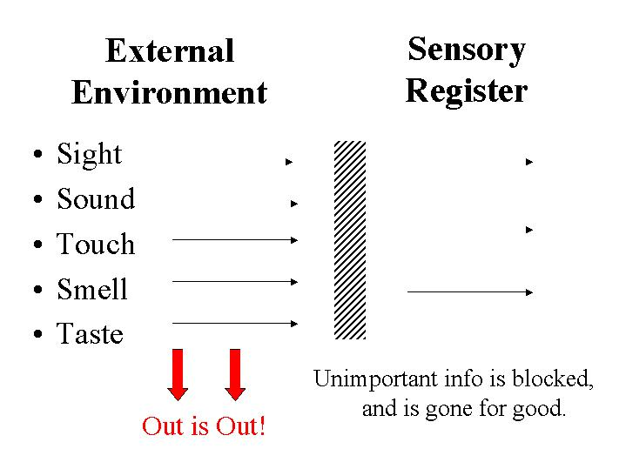

**Level 2**

The **short term memory** can retain information for up to approximately 30 seconds. Long enough to look up a phone number and dial it. Whether or not the information gets passed along to the next level depends on how important it is. If someone is faced with a survival crisis - a fire, a medical emergency, etc. - the brain will give its full attention to that need and any incoming information that is not related to that need will be lost. Likewise, if there are any emotional barriers because of circumstances - loss of a friend, divorce, pending move, etc. - the incoming data will be ignored and is gone for good. That information which does make it through moves to the next stage.

  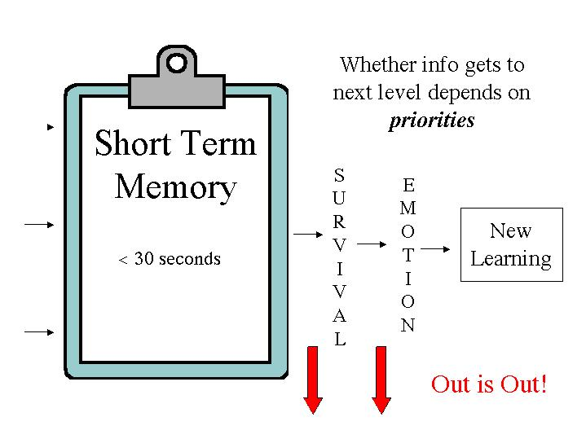

**Level 3**

Once data has made it into the **working memory** it means we are now deliberately, consciously processing it. The working memory is limited both in the amount of information it can deal with at one time and in how long it can remain focused on it. In general, both of these limits tend to increase - up to a point - with age.

We can keep this data on the work table of our working memory for 18-36 hours on average, although we have to vary the **way** in which we are processing it every 20 minutes or so. The working memory is the one that goes into overdrive during exam time as students cram as much information as possible into their overloaded brains at the last minute. However, since it is only in the working memory, it means that within 48 hours most of it is gone.

In addition, in the working memory we can only deal with 7 pieces of information (give or take) simultaneously. One technique used to get around this limitation, and increase the amount of data that can be worked on at the same time, is **chunking**. (You will find out more about chunking when you get to **Retention**.)

After being processed, practiced and manipulated, some of the information moves on to the next level and is finally placed into the long term memory. However, if that is to happen, the data must make sense to the person and/or have meaning. If they don't understand it, it is doubtful it will stick in the long run. If they see absolutely no point in remembering it, it is also highly unlikely that they will.

  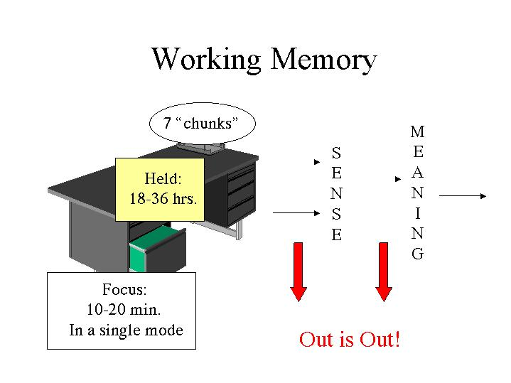

**Level 4**

Once the brain has assigned sense and/or meaning to the information it moves into the **long term memory**, and once it is in, it is there to stay.  How and where it is stored is another tale for another day, but it is worth noting that it is not a single linear progression. A single memory might be broken up into many pieces, each of which ends up residing in a different part of the memory.

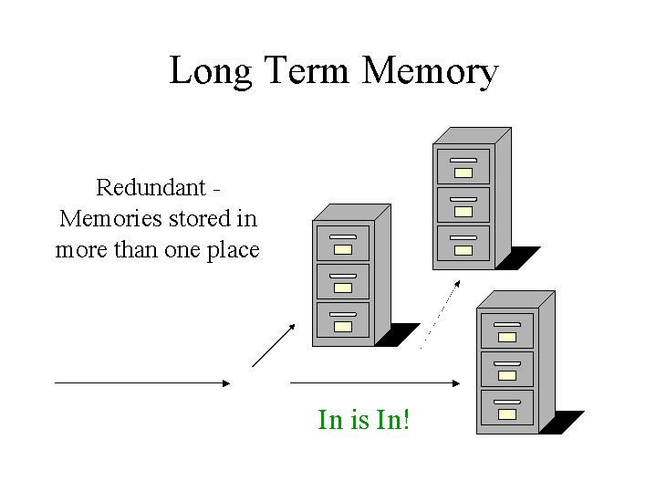

And, in a sense, the end of the process is also the beginning, because what we remember is often based on what we already know.   
 

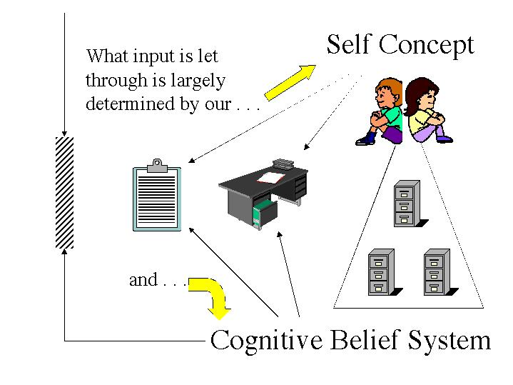

What we already know, what we believe and how we feel about ourselves are always working at our subconscious level. They determine right at the outset what information is let in through the sensory register. Past experience will cause us to be open to and interested in certain things, but it will also close the register and shut out input that we don't want to deal with.

Nummela & Caine would caution against oversimplification, as the above diagrams tend to do. They would also add the caveat that, while our capacity to focus our attention is limited, it appears that subconsciously our brain can continue to receive stimuli and process information even without our awareness that this is taking place.

It's a complicated and fascinating process. Research continues to shed light on the process, but we already know enough to make some serious improvements in how we educate students. What do we know? After the links, scroll down and continue.

**The Information Processing Approach to Cognition**

Citation: Huitt, W. (2003). The information processing approach to cognition. *Educational Psychology Interactive*. Valdosta, GA: Valdosta State University. Retrieved [date] from, <http://chiron.valdosta.edu/whuitt/col/cogsys/infoproc.html>

**Overview**

As stated in the [introduction](http://chiron.valdosta.edu/whuitt/col/cogsys/cogsys.html) to this section, cognitive psychology represents the dominant approach in psychology today. A primary focus of this approach is on [memory](http://www.psywww.com/mtsite/memory.html) (the storage and retrieval of information), a subject that has been [of interest for thousands of years](http://www.brainchannels.com/Memory/history.html). The most widely accepted theory is labeled the "stage theory," based on the work of Atkinson and Shriffin (1968). The focus of this model is on how information is stored in [memory](http://www.premiumhealth.com/memory/); the model proposes that information is processed and stored in 3 stages. In this theory, information is thought to be processed in a serial, discontinuous manner as it moves from one stage to the next. This theory is discussed in more detail below.

In addition to the [stage theory model](http://www.brainchannels.com/Memory/encoding/encoding.html) of information processing, there are three more that are widely accepted. The first is based on the work of Craik and Lockhart (1972) and is labeled the "**levels-of-processing**" theory. The major proposition is that learners utilize different levels of elaboration as they process information. This is done on a continuum from perception, through attention, to labeling, and finally, meaning. The key point is that all stimuli that activate a sensory receptor cell are permanently stored in memory, but that different levels of processing (i.e., elaboration) contribute to an ability to access, or retrieve, that memory. Evidence from hypnosis and forensic psychology provide some interesting support for this hypothesis. This approach has been extended by Bransford (1979) who suggests that it is not only how the information is processed, but how the information is accessed. When the demands for accessing information more closely match the methods used to elaborate or learn the information, more is remembered.

Two other models have been proposed as alternatives to the Atkinson-Shiffrin model: **parallel-distributed processing** and **connectionistic**. The parallel-distributed processing model states that information is processed simultaneously by several different parts of the memory system, rather than sequentially as hypothesized by Atkinson-Shiffrin as well as Craik and Lockhart. Work done on how we process emotional data somewhat supports this contention (see Goleman, 1995). The stage-theory model shown below differs slightly from the original Atkinson-Shriffin model in order to incorporate this feature.

The **connectionistic** model proposed by Rumelhart and McClelland (1986) extends the parallel-distributed processing model. It is one of the dominant forms of current research in cognitive psychology and is consistent with the most recent brain research (see Scientific American, 2000). This model emphasizes the fact that information is stored in multiple locations throughout the brain in the form of networks of connections. It is consistent with the levels-of-processing approach in that the more connections to a single idea or concept, the more likely it is to be remembered.

Even though there are widely varying views within cognitive psychology, there are a few basic principles that most cognitive psychologists agree with.

**General principles**

The first is the **assumption of a limited capacity** of the mental system. This means that the amount of information that can be processed by the system is constrained in some very important ways. Bottlenecks, or restrictions in the flow and processing of information, occur at very specific points.

A second principle is that a **control mechanism is required** to oversee the encoding, transformation, processing, storage, retrieval and utilization of information. That is, not all of the processing capacity of the system is available; an executive function that oversees this process will use up some of this capability. When one is learning a new task or is confronted with a new environment, the executive function requires more processing power than when one is doing a routine task or is in a familiar environment.

A third principle is that there is a **two-way flow of information** as we try to make sense of the world around us. We constantly use information that we gather through the senses (often referred to as bottom-up processing) and information we have stored in memory (often called top-down processing) in a dynamic process as we construct meaning about our environment and our relations to it. This is somewhat analogous to the difference between inductive reasoning (going from specific instances to a general conclusion) and deductive reasoning (going from a general principle to specific examples.) A similar distinction can be made between using information we derive from the senses and that generated by our imaginations.

A fourth principle generally accepted by cognitive psychologists is that the human organism has been **genetically prepared to process and organize information in specific ways**. For example, a human infant is more likely to look at a human face than any other stimulus. Given that the field of focus of a human infant is 12 to 18 inches, one can surmise that this is an important aspect of the infant's survival. Other research has discovered additional biological predispositions to process information. For example, language development is similar in all human infants regardless of language spoken by adults or the area in which they live (e.g., rural versus urban, Africa versus Europe.) All human infants with normal hearing babble and coo, generate first words, begin the use of telegraphic speech (e.g., ball gone), and over generalize (e.g., using "goed to the store" when they had previously used "went to the store") at approximately the same ages. The issue of language development is an area where cognitive and behavioral psychologists as well as cognitive psychologists with different viewpoints have fought many battles regarding the processes underlying human behavior. Needless to say the discussion continues.

**Stage Model of Information Processing**

One of the major issues in cognitive psychology is the study of [memory](http://www.pitt.edu/~suthers/infsci1042/memory.html). The dominant view is labeled the "stage theory" and is based on the work of Atkinson and Shiffrin (1968).

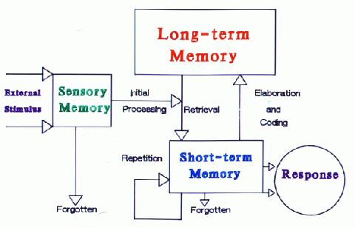

This model proposes that information is processed and stored in 3 stages.

**Sensory memory** (STSS). Sensory memory is affiliated with the transduction of energy (change from one energy from to another). The environment makes available a variety of sources of information (light, sound, smell, heat, cold, etc.), but the brain only understands electrical energy. The body has special sensory receptor cells that transduce (change from one form of energy to another) this external energy to something the brain can understand. In the process of transduction, a memory is created. This memory is very short (less than 1/2 second for vision; about 3 seconds for hearing).

It is absolutely critical that the learner attend to the information at this initial stage in order to transfer it to the next one. There are two major concepts for getting information into STM:

First, individuals are more likely to pay attention to a stimulus if it has an **interesting feature**. We are more likely to get an orienting response if this is present.

Second, individuals are more likely to pay attention if the stimulus activates a **known pattern**. To the extent we have students call to mind relevant prior learning before we begin our presentations, we can take advantage of this principle.

**Short-term memory** (STM). [Short-term memory](http://www.gpc.peachnet.edu/~bbrown/psyc1501/memory/stm.htm) is also called [working memory](http://www.brainconnection.com/topics/?main=fa/working-memory) and relates to what we are thinking about at any given moment in time. In Freudian terms, this is conscious memory. It is created by our paying attention to an external stimulus, an internal thought, or both. It will initially last somewhere around 15 to 20 seconds unless it is repeated (called maintenance rehearsal) at which point it may be available for up to 20 minutes. The hypothalamus is a brain structure thought to be involved in this shallow processing of information. The frontal lobes of the cerebral cortex is the structure associated with working memory. For example, you are processing the words you read on the screen in your frontal lobes. However, if I ask, "What is your telephone number?" your brain immediately calls that from long-term memory and replaces what was previously there.

Another major limit on information processing in STM is in terms of the number of units that can be processed at any one time. [Miller](http://www.well.com/user/smalin/miller.html) (1956) gave the number as 7 + 2, but more recent research suggests the number may be more like 5 + 2 for most things we are trying to remember. Because of the variability in how much individuals can work with (for some it may be three, for others seven) it is necessary to **point out important information**. If some students can only process three units of information at a time, let us make certain it is the most important three.

There are two major concepts for retaining information in STM: organization and repetition. There are four major types of organization that are most often used in instructional design:

* Component (part/whole)--classification by category or concept (e.g., the components of the [teaching/learning model](http://chiron.valdosta.edu/whuitt/materials/tchlrnmd.html));
* Sequential -- chronological; cause/effect; building to climax (e.g., [baking a cake](http://www.cakerecipe.com/default.asp), reporting on a research study);
* Relevance -- central unifying idea or criteria (e.g., most important principles of learning for [boys and girls](http://www.parentsoup.com/debate/learn/articles/0,12106,368787_368789,00.html), appropriate management strategies for middle school and high school students);
* Transitional (connective) -- relational words or phrases used to indicate qualitative change over time (e.g., stages in [Piaget's theory of cognitive development](http://chiron.valdosta.edu/whuitt/col/cogsys/piaget.html) or [Erikson's stages of socioemotional development](http://chiron.valdosta.edu/whuitt/col/affsys/erikson.html))

A related issue to organization is the concept of [chunking](http://daphne.palomar.edu/stat/mark/stm%20chunking.htm) or grouping pieces of data into units. For example, the letters "b d e" constitute three units of information while the word "bed" represents one unit even though it is composed of the same number of letters. Chunking is a major technique for getting and keeping information in short-term memory; it is also a type of elaboration that will help get information into long-term memory.

Repetition or [rote rehearsal](http://www.psybox.com/web_dictionary/Maintenance.htm) is a technique we all use to try to "learn" something. However, in order to be effective this must be done after forgetting begins. Researchers advise that the learner should not repeat immediately the content (or skill), but wait a few minutes and then repeat. For the most part, simply memorizing something does not lead to learning (i.e., relatively permanent change). We all have anecdotal evidence that we can remember something we memorized (a poem for example), but just think about all the material we tried to learn this way and the little we are able to remember after six months or a year.

**Long-term memory** (LTM). Long-term memory is also called preconscious and unconscious memory in Freudian terms. Preconscious means that the information is relatively easily recalled (although it may take several minutes or even hours) while unconscious refers to data that is not available during normal consciousness. It is preconscious memory that is the focus of cognitive psychology as it relates to long-term memory. The levels-of-processing theory, however, has provided some research that attests to the fact that we "know" more than we can easily recall. The two processes most likely to move information into long-term memory are elaboration and distributed practice (referred to as periodic review in the [direct instruction model](http://chiron.valdosta.edu/whuitt/col/instruct/instevnt.html)).

There are several examples of elaboration that are commonly used in the teaching/learning process:

* [imaging](http://www.psy.ohio-state.edu/psy312/imagery.html) -- creating a mental picture;
* [method of loci](http://www.happychild.org.uk/acc/tpr/mem/0898jour.htm) (locations)--ideas or things to be remembered are connected to objects located in a familiar location;
* [pegword](http://www.memory-key.com/mnemonics/list-learning.htm#The%20pegword%20mnemonic) method (number, rhyming schemes)--ideas or things to be remembered are connected to specific words (e.g., one-bun, two-shoe, three-tree, etc.)
* [Rhyming](http://www.fun-with-words.com/mnem_example.html) (songs, phrases)--information to be remembered is arranged in a rhyme (e.g., 30 days hath September, April, June, and November, etc.)
* [Initial letter](http://www.dsea.org/teachingtips/tips/skills.htm)--the first letter of each word in a list is used to make a sentence (the sillier, the better).

**Organization (types) of knowledge**

As information is stored in long-term memory, it is organized using one or more structures: declarative, procedural, and/or imagery.

**Declarative Memory** (generally refers to information we can talk about)

* Semantic Memory-- facts and generalized information ([concepts](http://pespmc1.vub.ac.be/ASC/Concept.html), principles, rules; problem-solving strategies; learning strategies)
  + [Schema / Schemata](http://pespmc1.vub.ac.be/ASC/Schema.html) -- networks of connected ideas or relationships; data structures or procedures for organizing the parts of a specific experience into a meaningful system (like a standard or stereotype)
  + Proposition -- interconnected set of concepts and relationships; if/then statements (smallest unit of information that can be judged true or false)
  + Script -- "declarative knowledge structure that captures general information about a routine series of events or a recurrent type of social event, such as eating in a restaurant or visiting the doctor" (Stillings et al., 1987)
  + [Frame](http://pespmc1.vub.ac.be/ASC/Frame_refer.html) -- complex organization including concepts and visualizations that provide a reference within which stimuli and actions are judged (also called "Frame of Reference")
  + Scheme -- an organization of concepts, principles, rules, etc. that define a perspective and presents specific action patterns to follow
  + [Program](http://pespmc1.vub.ac.be/ASC/Program.html) -- set of rules that define what to do in a particular situation
  + [Paradigm](http://www.valdosta.peachnet.edu/whuitt/col/intro/paradigm.html) -- the basic way of perceiving, thinking, valuing, and doing associated with a particular vision of reality (Harman, 1970)
  + [Model](http://pespmc1.vub.ac.be/ASC/MODEL.html) -- a set of propositions or equations describing in simplified form some aspects of our experience. Every model is based upon a theory or paradigm, but the theory or paradigm may not be stated in concise form. (Umpleby in Principia Cybernetica Web, no date)
* Episodic Memory-- personal experience (information in stories and analogies)

**Procedural Memory**-- how to (driving a car, riding a bike)

**Imagery** -- pictures

**Concept formation**

    One of the most important issues in cognitive psychology is the development or formation of concepts. A concept is the set of rules used to define the categories by which we group similar events, ideas or objects. There are several principles that lend themselves to concept development:

* name and define concept to be learned (advance organizer)  
  a. reference to larger category  
  b. define attributes
* identify relevant and irrelevant attributes (guided discovery)
* give examples and nonexamples (tie to what is already known -- elaboration)
* use both inductive (example/experience --> definition) and deductive reasoning (definition --> examples)
* Name distinctive attributes (guided discovery)

|  |  |
| --- | --- |
| **USING THE INFORMATION PROCESSING APPROACH IN THE CLASSROOM** | |
| **Principle** | **Example** |
| 1. Gain the students' attention. | * Use cues to signal when you are ready to begin. * Move around the room and use voice inflections. |
| 2. Bring to mind relevant prior learning. | * Review previous day's lesson. * Have a discussion about previously covered content. |
| 3. Point out important information. | * Provide handouts. * Write on the board or use transparencies. |
| 4. Present information in an organized manner. | * Show a logical sequence to concepts and skills. * Go from simple to complex when presenting new material. |
| 5. Show students how to categorize (chunk) related information. | * Present information in categories. * Teach inductive reasoning. |
| 6. Provide opportunities for students to elaborate on new information. | * Connect new information to something already known. * Look for similarities and differences among concepts. |
| 7. Show students how to use coding when memorizing lists. | * Make up silly sentence with first letter of each word in the list. * Use mental imagery techniques such as the keyword method. |
| 8. Provide for repetition of learning. | * State important principles several times in different ways during presentation of information (STM). * Have items on each day's lesson from previous lesson (LTM). * Schedule periodic reviews of previously learned concepts and skills (LTM). |
| 9. Provide opportunities for overlearning of fundamental concepts and skills. | * Use daily drills for arithmetic facts. * Play form of trivial pursuit with content related to class. |

**References:**

* Atkinson, R., & Shiffrin, R. (1968). Human memory: A proposed system and its control processes.In K Spence & J Spence (Eds.). T*he psychology of learning and motivation: Advances in research and theory* (Vol. 2). New York: Academic Press.
* Bransford, J. (1979). *Human cognition: Learning, understanding, and remembering.* Belmont, CA: Wadsworth.
* Craik, F., & Lockhart, R. (1972). Levels of processing: A framework for memory research. *Journal of Verbal Thinking and Verbal Behavior, 11,* 671-684*.*
* Goleman, D. (1995). *Emotional intelligence: Why it can matter more than IQ for character, health and lifelong achievement*. New York: Bantam Books.
* Harman, W. (1970). *An incomplete guide to the future*. New York: W. W. Norton.
* Miller, G. A. (1956). [The magical number seven, plus or minus two: Some limits on our capacity for processing  
  information](http://www.well.com/user/smalin/miller.html). *Psychological Review, 63*, 81-97. [Available online from *Classics in the History of Psychology*.]
* Rumelhart, D., & McClelland, J. (Eds.). (1986). *Parallel distributed processing: Explorations in the microstructure of cognitio*n*.* Cambridge, MA: MIT Press.
* Scientific American (eds.). (1999). *The Scientific American book of the brain*. New York: The Lyons Press.
* Stillings, N, Feinstein, M., Garfield, J., Rissland, E., Rosenbaum, D., Weisler, S., & Baker-Ward, L. (1987). *Cognitive science: An introduction*. Cambridge, MA: MIT Press.
* Principia Cybernetica Web. (no date). [*Model*](http://pespmc1.vub.ac.be/ASC/MODEL.html). Author.