The Nike Shoe Investigation – Map of the Pacific Ocean

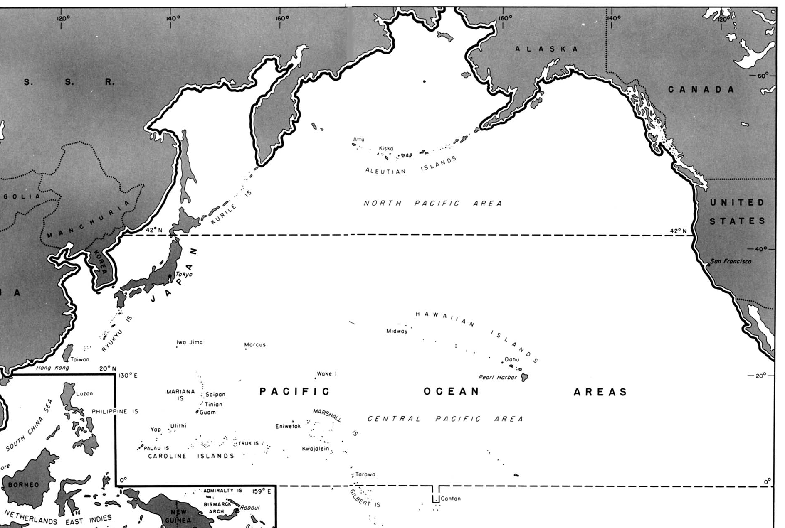

The Nike Shoe Investigation Name _____________________________

On May 27, 1990 the freighter Hansa Carrier, enroute from Korea to the U.S., encountered a severe North Pacific storm. During the storm, a large wave washed twenty-one shipping containers overboard. Five of these 20-meter containers held a shipment of approximately 80,000 Nike shoes ranging from children’s shoes to large hiking boots. It has been estimated that four of the five containers opened into the stormy waters, releasing over 60,000 shoes into the North Pacific Ocean. The shoes washed ashore one at a time but were wearable after a scrub-down to remove barnacles, algae, and tar. Beachcombers held swap meets to find matched pairs. In this investigation we will consider the starting point for the ocean adventure these shoes had, look at the places where shoes washed ashore, then make some conclusions about the general circulation patterns in the Pacific Ocean.



Procedure:
- Plot the location of each shoe discovery on the map. Number 1-11.
- For each point label how many shoes were found AND the date they were found.
- Draw arrows on the map to show how the ocean currents moved the shoes.
- Answer the questions on the back.

Data:
 |  | Date | Latitude and Longitude
1 | Shoes lost overboard! | May 27, 1990 | 48°N, 161°W
2 | 200 shoes recovered | November 1, 1990 | 49°N, 126°W
3 | 100 shoes recovered | February, 1991 | 53°N, 131°W
4 | 200 shoes recovered | February, 1991 | 47°N, 125°W
5 | 250 shoes recovered | March 26, 1991 | 59°N, 139°W
6 | 150 shoes recovered | April 4, 1991 | 44°N, 124°W
7 | 200 shoes recovered | May 9-10, 1991 | 40°N, 124°W
8 | 200 shoes recovered | May 18, 1991 | 55°N, 130°W
9 | Several shoes recovered | January 1, 1993 | 19°N, 155.5°W
10 | Several shoes recovered | January, 1994 | 32°N, 132°E Yes, EAST!
11 | Several shoes recovered | April, 1996 | 54°N, 133°W

Questions:
- After looking at the data you plotted on your map, write a sentence or two describing the path taken by the drifting shoes.

- Find the part of the map that shows the journey the shoes took from where they fell off the boat to where they first washed up on shore. Answer the following questions about that part of their journey.

  - What is the name of the ocean current that moved the shoes from the boat to the shore?

_______________________________

  - Considering that the scale of the map is 1 inch equals 800 miles, use a ruler to estimate the distance the shoes traveled from the boat to the shore.

_________________ miles

  - How many days did it take the shoes to travel from the boat to the shore?

________________ days

  - How many miles per day did the shoes travel from the boat to the shore?

_________________ miles per day

- Find the part of the map that shows where the shoes moved from California to Hawaii. Answer the following questions about that part of their journey.

  - What are the names of the two ocean currents that moved the shoes from California to Hawaii?

_______________________ ______________________

  - Considering that the scale of the map is 1 inch equals 800 miles, use a ruler to estimate the distance the shoes traveled from California to Hawaii.
(HINT: Don’t measure a straight line from California to Hawaii. The shoes probably traveled south from California and then curved west towards Hawaii.)

___________________ miles

  - How many days did it take the shoes to travel from California to Hawaii?

___________________ days

  - How many miles per day did the shoes travel from California to Hawaii?

___________________ miles per day

- TRUE or FALSE - All ocean currents move at the same speed.

- What is the name of the ocean current that took the shoes past Japan? ________________________

