Gandhi Web Quest

Your goal is to do some research to learn a bit about one of history’s most important and influential peacemakers: Mohandas Gandhi.

Answer as many of the following questions as you can in the class period. There are some links provided if you need help getting started.

Write down your responses so that they may be turned in at the end of the class period.

Questions:

1. Who was Gandhi? When and where did he live? Why was he important?

2. How was his life related to peace? What did he sacrifice to achieve peace?

3. What was Gandhi’s most important accomplishment?

4. Which of Gandhi’s ideas do you most like or dislike? What do you most agree or disagree with? What questions do you have?

http://www.gandhiserve.org/

http://www.mkgandhi.org/
http://www2.lucidcafe.com/lucidcafe/library/95oct/mkgandhi.html
http://www.sscnet.ucla.edu/southasia/History/Gandhi/gandhi.html
http://www.mkgandhi.org/articles/speechnm1.htm
5. What impact did Gandhi have on the United States?

http://www.heritagepreservation.org/PROGRAMS/SOS/4KIDS/mlk.htm

http://www.scholastic.com/teachers/article/life-and-words-martin-luther-king-jr-part-1-2

6. Select at least one of Gandhi’s quotes that you find to be meaningful. Explain what this quote means to you and why you selected it.

http://www.fiu.edu/~fcf/Gandhi.quotes.html

Gandhi Web Quest Continued

8. What might Gandhi say about the following information? What is your opinion?

http://www.worldometers.info/

7. Develop a creative response to show your thoughts and feelings about one or more aspects of Gandhi’s life.
- Examine the images below and write a creative response.
- Write a letter to or from Gandhi.
- Create a text conversation between Gandhi and someone else, perhaps yourself
- Draw an aspect of Gandhi’s life.
- Write an obituary for Gandhi. An obituary is a remembrance of someone after she or he passes away.
- Write a letter to our president explaining what the US should most learn from Gandhi.
- Create a comic strip related to Gandhi
- Come up with your own idea.

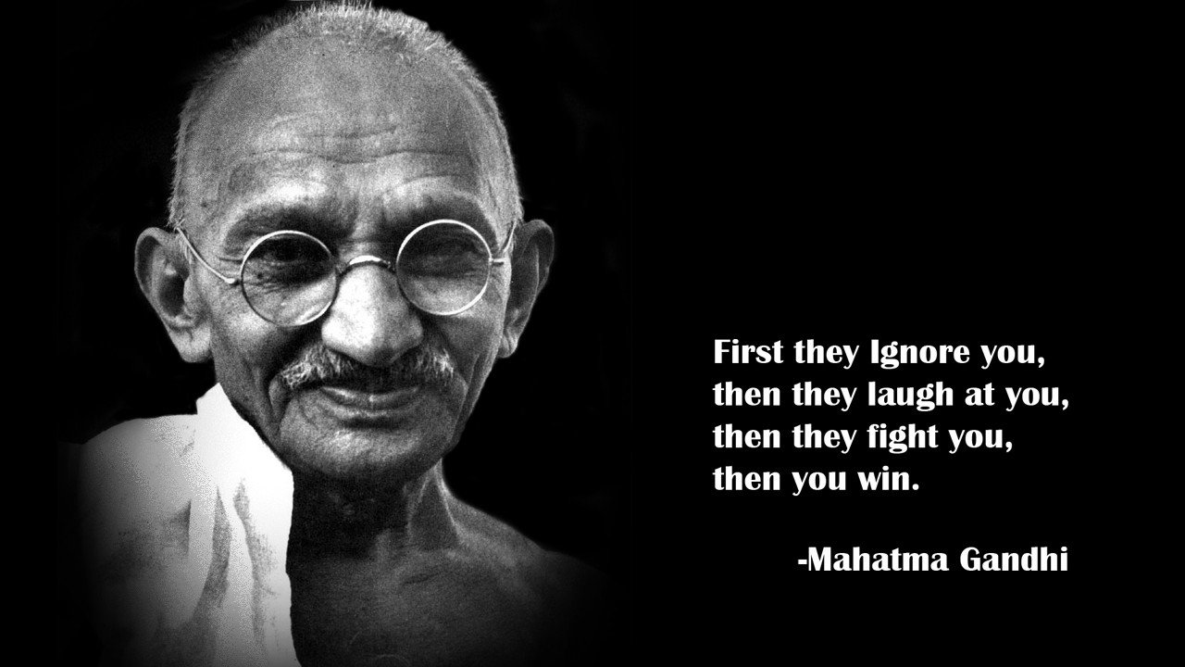
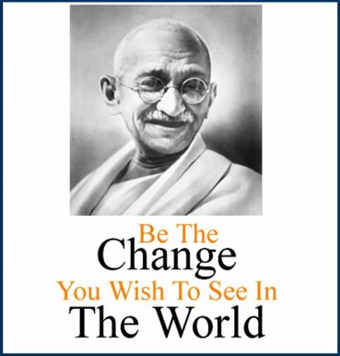

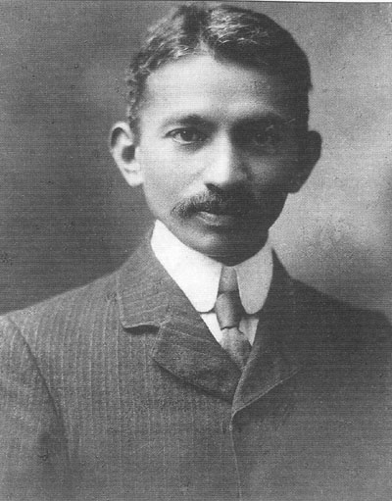
Gandhi in South Africa, 1909

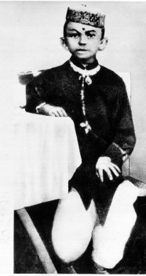
Gandhi in his earliest know photograph, age 7. 1876.

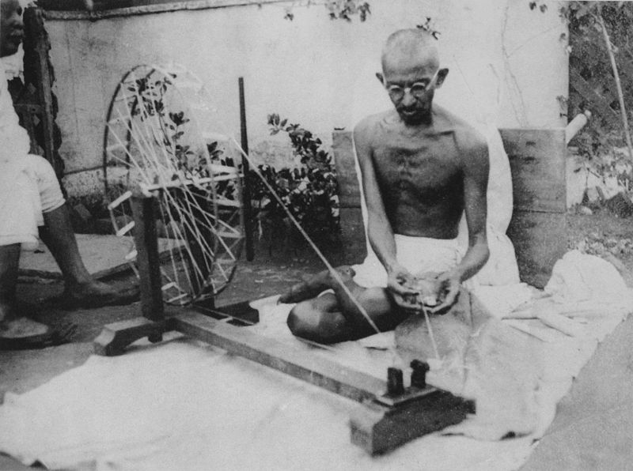Gandhi spinning yarn for clothes in the 1920s

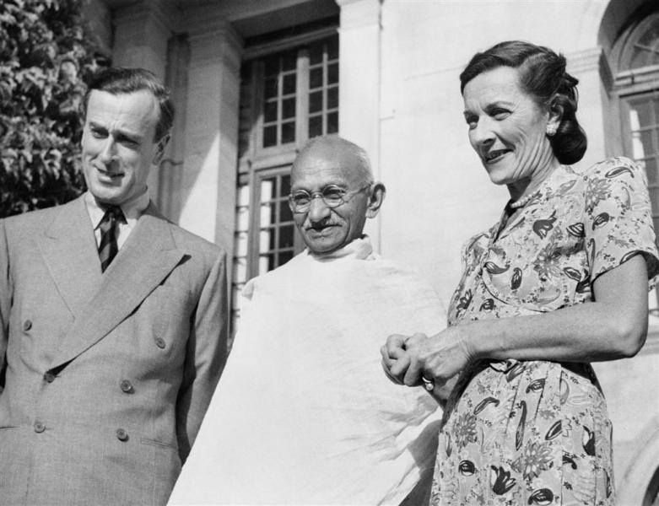
Gandhi with Louis Mountbatten , Britain's last Viceroy of India, 1947

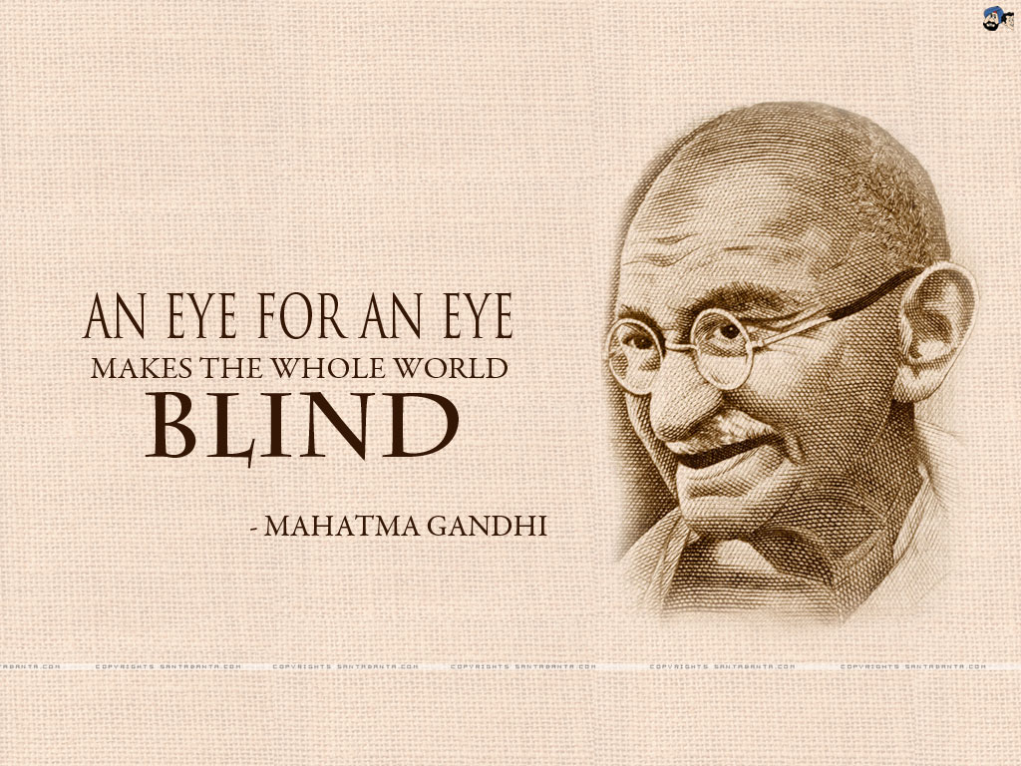

April 4, 2013 Surgical Paralysis Ordered in Saudi Arabia as Punishment for Teenage Assault

Ali Al-Khawahir, 24, is awaiting court-ordered surgical paralysis in Saudi Arabia for an assault he committed when he was 14 years old, according to news reports.

Al-Khawahir has reportedly spent 10 years in prison since stabbing a friend in the spine during a fight. The wound left his friend paralyzed. The Saudi legal system allows eye-for-an-eye punishments.

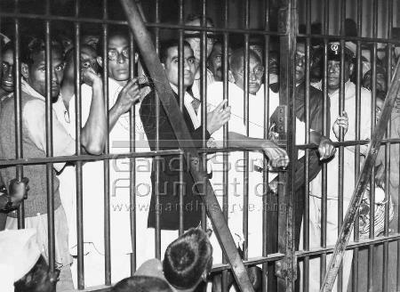
Gandhi in jail in Calcutta, India. 1946

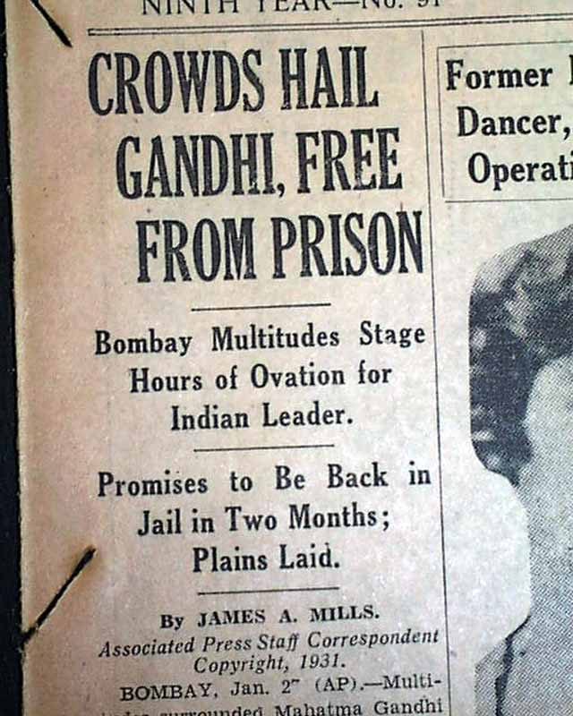

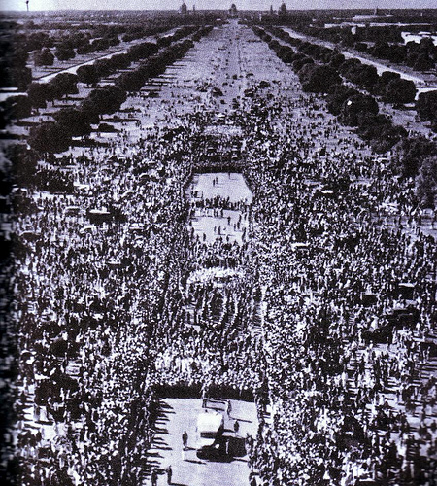
A view of Gandhi’s funeral procession

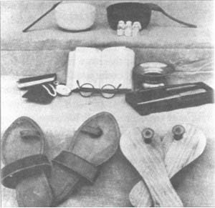
All that Gandhi owned in the world upon his death, in 1948.

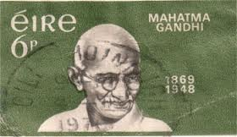
Irish stamp

