**Worksheet 4.2B- Fuel Economy- ANSWERS**

Here are advertised horsepower ratings and expected gas mileage for several 2007 vehicles as reported by Kelly Blue Book.

|  |  |  |  |  |  |
| --- | --- | --- | --- | --- | --- |
| **Vehicle** | **Horsepower** | **Highway Gas Mileage (mpg)** | **Vehicle** | **Horsepower** | **Highway Gas Mileage (mpg)** |
| Audi A4 | 200 | 32 | Honda Accord | 166 | 34 |
| BMW 328 | 230 | 30 | Hyundai Elantra | 138 | 36 |
| Buick LaCrosse | 200 | 30 | Lexus IS 350 | 306 | 28 |
| Chevy Cobalt | 148 | 32 | Lincoln Navigator | 300 | 18 |
| Chevy TrailBlazer | 291 | 22 | Mazda Tribute | 212 | 25 |
| Ford Expedition | 300 | 20 | Toyota Camry | 158 | 34 |
| GMC Yukon | 295 | 21 | Volkswagen Beetle | 150 | 30 |
| Honda Civic | 140 | 40 |  |  |  |

1. Create a scatterplot of horsepower(exp.) vs. mpg(resp.) and draw it below. Describe the form, direction, and strength. Are there any unusual features? (4)

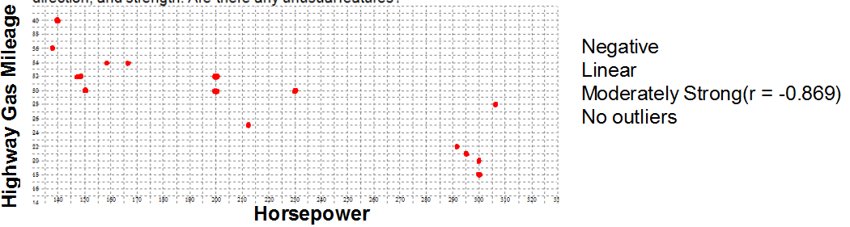

1. Describe the scatterplot (3)

Negative, linear, moderately strong

1. Find the equation of the LSRL using the calculator. (3)

y = -0.084x + 46.868

1. What is the slope of the line? Describe it in the context of the problem. (3)

slope = -0.084

For every increase of 1 horsepower there tends to be a decrease of 0.084 mpg in the highway gas mileage.

1. What is the y-intercept of the line? Describe it in the context of the problem. (3)

y-intercept = 46.868

A car with 0 horsepower would have a highway gas mileage of 0 mpg.

1. What is the correlation? (1)

r = -0.869

1. What mpg does the LSRL predict for a car with 295 horsepower? (2)

y = -0.084(295) + 46.868

y = 22.088 mpg

1. What mpg does the LSRL predict for a car with 140 horsepower? (2)

y = -0.084(140) + 46.868

y = 35.108 mpg

1. Find the residuals for each of the last two problems. (4)

e = 21 – 22.088 e = 40 – 35.108

e = -1.088 mpg e = 4.892 mpg

1. For each prediction was it an overestimation or an underestimation? How can you tell? (4)

Overestimate Underestimate

Predicted bigger Actual bigger

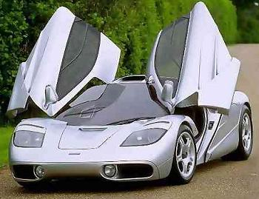

1. The McLaren F1 has a horsepower of 627. What would the LSRL predict as its mpg? (2)

y = -0.084(627) + 46.868

y = -5.8 mpg

1. Why might you not trust the validity of prediction you made in #11? (1)

It is far outside the data range. Prediction could be incorrect because of extrapolation.

1. It actually has a mpg of 12. What is the residual? Is this an overestimation or underestimation? (3)

e = 12 – (-5.8)

e = 17.8 mpg

underestimation

1. What is the coefficient of determination? Interpret this number. (3)

74.46% of the change in the MPG is due to the change in the Horsepower.