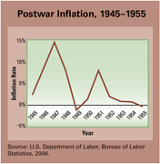Harry Truman had never wanted to be president. The day after he learned of Franklin Roosevelt’s death on April 12, 1945, he told reporters,

Boys, if you ever pray, pray for me now. I don’t know whether you fellows ever had a load of hay fall on you, but when they told me yesterday what had happened, I felt like the moon, the stars, and all the planets had fallen on me.

—Harry Truman, 1945

Truman’s first task was to bring the war to an end. Once that was done, he faced the enormous challenge of leading the country back to a peacetime economy.

**A Rocky Transition to Peace**

Truman welcomed the war’s end by announcing a package of reforms that later came to be known as the **Fair Deal.** He called on Congress to increase the minimum wage, increase aid to agriculture and education, and enact a national health insurance program. Complaining that Truman was “out–New Dealing the New Deal,” Republicans in Congress did their best to stall his reforms.

Meanwhile, the economy was going through a difficult period of adjustment. As the war came to a close, government officials canceled billions of dollars’ worth of war contracts. As a result, millions of defense workers lost their jobs. In addition, once wartime price controls were lifted, prices skyrocketed.

As **inflation** soared, workers demanded wage increases. When employers refused to meet these demands, labor unions triggered the largest strike wave in U.S. history. In 1946, nearly 5 million workers walked off the job, many of them in such key industries as steel production, coal mining, and oil refining.

When railroad workers went on strike, Truman took action. In a speech to Congress, he warned, “Food, raw materials, fuel, shipping, housing, the public health, the public safety—all will be dangerously affected” if the strike were allowed to continue. Truman threatened to call out the armed forces to run the railroads. However, the strike was settled before he could carry out his threat.

### Truman Battles a Republican Congress

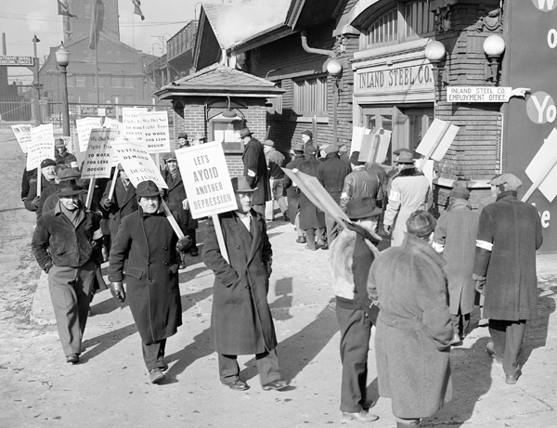The labor unrest was still fresh in voters’ minds as the 1946 congressional elections drew near. Running under the slogan “Had Enough?” Republican candidates swept to victory. For the first time since the 1920s, Republicans gained control of both houses of Congress.

One of the first actions of the new Republican Congress was passage of the Twenty-second Amendment in 1947. This amendment limits a president to two terms of office. The Republican sponsors of the amendment did not want to see another liberal president like Franklin Roosevelt seek four terms as president. They argued that without term limits, a popular president might seek to become “president for life,” much like a dictator. The amendment was overwhelmingly ratified by the states and was added to the Constitution in 1951.

Congress also took aim at the labor unions by passing the **Taft-Hartley Act** in 1947. This law placed many limits on the power of unions. Among other things, it outlawed the closed shop. A closed shop is a workplace in which the employer agrees to hire only members of a particular union. It banned sympathy strikes, in which workers of one union walk off their jobs to show their sympathy with another striking union. It also allowed the president to impose an 80-day “cooling off” period before a union could strike in certain industries. This provision especially enraged union supporters, who called it “slave labor law.” President Truman vetoed the law, but Congress passed it over his veto.

Truman also battled with Congress over civil rights. Late in 1946, he established the President’s Committee on Civil Rights to investigate racial inequality in the United States. The committee issued a report calling for an end to segregation and discrimination in voting, housing, education, employment, and the military. Truman praised the report as “an American charter of human freedom.” Congress, however, refused to act on its recommendations. In 1948, Truman sidestepped Congress and desegregated the armed forces by executive order.

**An Upset Victory in 1948**

As the election of 1948 drew near, Democrats were filled with gloom. Truman, who had been unable to get any of his reforms passed by the Republican Congress, looked like a weak candidate. Worse yet, the Democratic Party had splintered into three factions.

Left-wing Democrats, led by former U.S. vice president Henry Wallace, pulled away to form the Progressive Party. Wallace was more liberal than Truman on domestic issues. But his main difference with the president was over foreign policy. Fearing that Truman’s hard-line containment policy could lead to World War III, he advocated friendlier relations with the Soviet Union.

Segregationist southern Democrats, known as Dixiecrats, left to form the States’ Rights Democratic Party. The Dixiecrats nominated Strom Thurmond, the governor of South Carolina, for the presidency. Thurmond ran on a platform of complete segregation of the races.

The Republicans nominated New York governor Thomas E. Dewey to run against Truman. Dewey was heavily favored to win, despite his lackluster campaign style. One newspaper ran this parody of the typical, bland Dewey speech: “Agriculture is important. Our rivers are full of fish. You cannot have freedom without liberty. Our future lies ahead.”

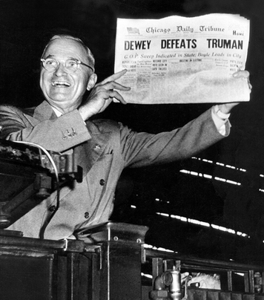Truman decided to fight for the presidency. He launched an ambitious “whistle-stop” tour of the country. A whistle-stop is a small town where a train would stop only if signaled to do so by a whistle. During his tour, Truman made 356 stops to speak directly to voters. At every one, he lambasted the “do nothing” Republican Congress. His supporters cheered him on with the slogan, “Give ’em hell, Harry!”

On election eve, opinion polls predicted a Dewey landslide. Only Truman seemed to believe he could win. The voters proved Truman right. In one of the biggest electoral upsets in history, Truman narrowly won reelection.

For the next four years, Truman regularly presented his Fair Deal programs to Congress. However, a coalition of conservative southern Democrats and mid-western Republicans blocked most of his reform efforts. Congress did agree to a modest expansion of Social Security benefits. It also agreed to increase the minimum wage and support slum clearance.

**Ike Takes the Middle of the Road**

During the 1952 election season, the Democratic Party came together again around Adlai Stevenson, the governor of Illinois. Stevenson was much admired for his elegant speaking style and wit.

The Republicans nominated the immensely popular war hero Dwight D. Eisenhower. Eisenhower had an impressive biography. After serving as supreme commander of the Allied forces in Europe during World War II, he had gone on to become head of NATO. Moreover, people loved Eisenhower’s winning smile and agreeable manner. Building on his nickname, Ike, the Republican campaign featured posters and buttons saying, “I like Ike.”

Richard Nixon, a young senator from California, was chosen to be Eisenhower’s running mate. A strong anticommunist, Nixon had gained prominence as a member of the House Un-American Activities Committee. In the election, Eisenhower swept to victory in 39 of the 48 states. Four years later, he again defeated Stevenson to win a second term as president.

During his presidency, Eisenhower embraced a program he described as “modern Republicanism.” He promised to be “conservative when it comes to money and liberal when it comes to human beings.” He resisted calls by conservatives to roll back the New Deal. “Should any political party attempt to abolish Social Security, unemployment insurance, and eliminate labor laws and farm programs,” he warned, “you would not hear of that party again in our political history.” Eisenhower went further and expanded Social Security. By doing so, he ensured that this popular New Deal program would survive no matter which party controlled the White House.

At the same time, Eisenhower presided over a massive peacetime arms buildup. “Our arms,” he stated, “must be mighty, ready for instant action.” Still, he worried about the growing power of what he called the “military-industrial complex.” In his last address as president, Eisenhower warned,

This conjunction [joining] of an immense military establishment and a large arms industry is new in the American experience . . . We recognize the imperative need for this development. Yet . . . we must never let the weight of this combination endanger our liberties or democratic processes.

—Dwight D. Eisenhower, Farewell Address, 1961

**Consumer Demand Spurs Economic Growth**

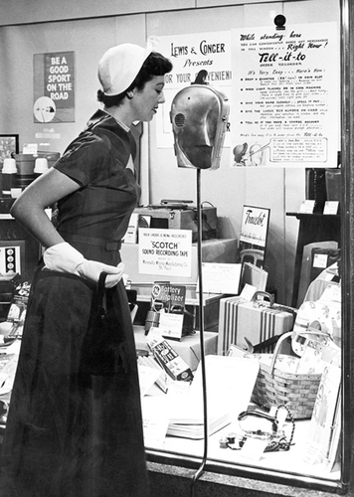During World War II, Americans had saved billions of dollars. Flush with cash, they were ready to go on a spending spree as soon as factories could convert from war production to consumer goods. This surge in consumer demand encouraged businesses to expand production. By 1955, the United States, with only 6 percent of the world’s population, was producing almost half of the world’s goods.

As the economy grew, incomes rose. **Real income** is income measured by the amount of goods and services it will buy, regardless of inflation. By the mid-1950s, the average American family had twice as much real income to spend as the average family of the 1920s had. And spend it they did.

Not only were Americans spending more money than ever before, they were also spending it in different places. In the past, most people had bought their goods in stores lining the main street of town. By the mid-1950s, however, suburban shopping centers were luring consumers away from downtown shopping districts. Shopping centers offered customers easy parking and a wide array of shops to browse, often in air-conditioned comfort. By 1964, there were more than 7,600 shopping centers across the United States.

Businesses used methods pioneered during the 1920s to encourage consumers to keep on spending. One method was slick advertising campaigns. By 1955, businesses were spending $8 billion a year on ads that encouraged consumption.

Another method was to offer consumers easier ways to buy now and pay later. Large stores issued charge cards that allowed their customers to charge goods to an account rather than pay cash. By 1960, Sears Roebuck had more than 10 million accounts, or one for every five families. In 1958, American Express launched the first all-purpose credit card that could be used in stores, hotels, restaurants, and gas stations.

A third method used to encourage consumption was called **planned obsolescence**. Brooks Stevens, the industrial designer who popularized this term, defined it as a way to create “the desire to own something a little newer, a little better, a little sooner than is necessary.” Businesses using this method looked for ways to make what a consumer bought today seem obsolete, or out-of-date, after a fixed period of time. Clothing companies did this by introducing new fashions every season. As they did so, last season’s garments, although still usable, looked dated. Automobile companies did the same thing by changing the styling of their cars every year.

**The Economy Begins to Shift from Goods to Services**

When the 1950s began, the U.S. economy was dominated by industries that produced such goods as steel, appliances, and cars. By the end of the decade, industries that provided services, rather than manufacturing goods, were growing in importance. The biggest and best-known manufacturing company was the automaker General Motors. In 1955, GM became the first U.S. corporation to earn more than $1 billion a year. It accomplished this feat by producing and selling as many cars as all of its competitors produced combined.

An important factor in GM’s success was an improved relationship with its workers. In 1948, GM signed a historic agreement with the United Auto Workers union. The agreement guaranteed that GM workers would receive regular wage hikes tied to a **cost-of-living index.** A cost-of-living index measures differences in the price of goods and services over time. If inflation pushes prices up, the index measures by how much prices went up. *Fortune* magazine called the agreement “the treaty of Detroit.” It brought GM years of labor peace.

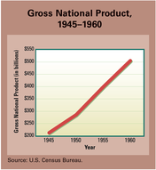As the economic boom continued, new service industries began to compete for the consumer’s dollar. One was the fast-food service industry. In 1954, a go-getter named Ray Kroc visited McDonald’s Famous Hamburgers in San Bernardino. He was amazed by what he saw. An hour before lunch, there was already a long line of customers waiting to be served. Kroc asked people in line what they liked about the restaurant. They replied that it was clean, fast, and cheap. In addition, the burgers tasted good, and it was not necessary to tip anyone.

Kroc convinced the McDonald brothers to hire him as a franchising agent. A **franchise** is an agreement to operate a business that carries a company’s name and sells its products. The next year, he opened his own franchise restaurant in Des Plains, Illinois. Like the original, Kroc’s McDonald’s was wildly successful. It was especially attractive to families with young children who did not feel comfortable in more formal restaurants. Under Kroc’s leadership, hundreds of McDonald’s soon dotted the landscape. By 1963, the fast-food chain had sold more than 1 billion hamburgers.

Another new service industry, the motel chain, was inspired by a summer driving trip. In 1951, Kemmons Wilson, a homebuilder in Tennessee, took his family on a car trip to Washington, D.C. Day after day, he faced the problem of finding a decent place for his family to spend the night. Motels at that time were independent, mom-and-pop operations. Some were clean. Others were filthy. Some charged extra for children. Others did not. The only way to find out was to go from one motel to the next.

A frustrated Wilson finally turned to his wife and announced he was going into the motel business. She asked how many motels he planned to build. “Oh, about four hundred,” he answered. “That ought to cover the country.” His motels would be clean, affordable, easy to find, and family-friendly. “If I never do anything else worth remembering in my life,” he added, “children are going to stay free at my motels.” Wilson returned home and built his first Holiday Inn. After franchising his chain, the number of Holiday Inns grew rapidly. Other chains, such as Best Western and Howard Johnson’s, also began to expand. By the 1960s, the motel chain had become a fixture on America’s highways.

**The Workforce Shifts from Blue- to White-Collar Jobs**

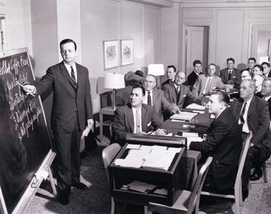As the economy grew and changed, the kinds of work people did also changed. When the 1950s began, **blue-collar workers** made up the largest part of the workforce. Blue-collar workers are people who work in factories or at skilled trades, such as plumbing or auto repair. Most are paid by the hour. The name comes from the durable blue shirts that manual workers often wore to work.

By the end of the 1950s, the workforce looked different. For the first time in history, **white-collar workers** outnumbered blue-collar employees. White-collar workers include professionals such as doctors and lawyers, engineers, salespeople, managers, and office staff. Most receive a weekly or yearly salary rather than an hourly wage. Because white-collar employees worked in offices, they could wear white shirts to work without fear of getting them dirty.

Both groups prospered during the 1950s. As blue-collar workers moved up into the middle class, they began to dress, act, and consume like their white-collar neighbors. “During the war,” observed a sociologist in Detroit, “you could sit on a streetcar and tell at a glance who were the [blue-collar] defense workers and who were the white collars . . . Today you just can’t tell who’s who.”

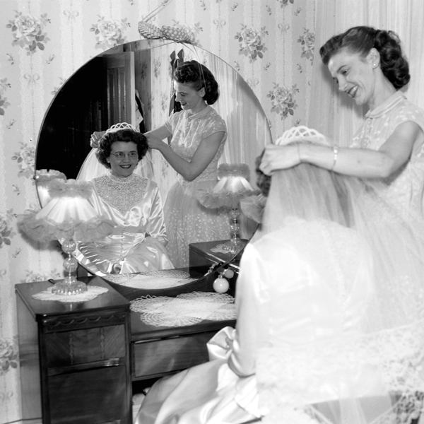The year 1946 was one second old when a navy machinist’s wife gave birth to a baby girl in Philadelphia. In Chicago, seconds after the new year began, a son was born to the wife of an army trombone player in Chicago. For both sets of parents, these births may have been long-awaited and happy events. But for demographers who study the growth of human populations, these births marked the beginning of the largest population boom in U.S. history.

**A Marriage Boom Leads to a Baby Boom**

During the Depression, marriage rates and birthrates had dropped as worries about the future caused people to postpone decisions that would change their lives. After World War II ended, the future looked brighter. In 1946, there were almost 2.3 million marriages in the United States, an increase of more than 600,000 from the year before. More people were marrying—and at younger ages—than during the war years. The average age of marriage in the 1950s was 20 for women and 22 for men.

Many of these newlyweds started families right away. Older couples who had delayed having children also began to start families. “It seems to me,” observed a visitor from Great Britain, “that every other young housewife I see is pregnant.” The result was a **baby boom** a large increase in the number of babies born in proportion to the size of the population. At the peak of the baby boom, in 1957, 4.3 million births were recorded. By 1964, the last baby boom year, four Americans in ten were under the age of 20.

Economists and businesspeople were thrilled by the baby boom. Signs in New York City subway cars informed riders that

Your future is great in a growing America.  
Every day 11,000 babies are born in America.  
This means new business, new jobs, new opportunities.

The babies overflowing maternity wards boosted sales for diaper services and baby food bottlers. Home sales boomed as young families flocked to the suburbs in search of living space. Factories worked overtime to fill these new homes with furniture and appliances and to put a car in every garage.

Schools had trouble finding room for the millions of children reaching school age each year. During the 1950s, California opened new schools at the rate of one a week to make room for the baby boomers. Older schools added temporary buildings to create more classrooms. Other schools handled the flood by running two shifts of classes, one in the morning and another in the afternoon. Despite these efforts, large classes with two students to a desk were common during the 1950s.

**Family Roles: Working Dads and Stay-at-Home Moms**

The majority of baby boomers grew up in so-called traditional families, with dads who went to work each day and moms who stayed home. The importance of marriage and family was driven home in marriage manuals of the day. “Whether you are a man or a woman, the family is the unit to which you most genuinely belong,” wrote Dr. John Schindler in *The Woman’s Guide to Better Living 52 Weeks a Year*. “The family is the center of your living. If it isn’t, you’ve gone far astray.”

The belief that mothers should not work outside the home unless they had to for economic reasons was promoted by Dr. Benjamin Spock, the leading childcare expert of the day. First published in 1946, Spock’s *Common Sense Book of Baby and Child Care* was a best seller for many years. Spock advised mothers to devote themselves full-time to raising their children. Any distraction from that task, such as a job or hobby, he argued, could damage a young child.

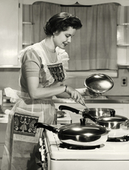The mass media reinforced traditional family roles. Magazines, movies, and advertisements portrayed the ideal family as one in which the husband was the breadwinner while the wife stayed home. The homemaker’s role was expanded to include a number of jobs. A mom became a teacher, doctor, nurse, cook, adviser, decorator, housekeeper, manager, and chauffeur all in one.

A new medium called television brought this ideal family to life on screen. In *Leave It to Beaver*, June Cleaver was a stay-at-home mom who wore high heels and pearls while working in the kitchen. When asked what kind of girl her son Wally should marry, she answered, “Oh, some sensible girl from a nice family . . . who’s a good cook and can keep a nice house and see that he’s happy.” Jim Anderson, the sensible dad in *Father Knows Best*, calmly solved his family’s problems when he got home from work. In one episode, he advised his tomboy daughter Kathy to act helpless around boys. “The worst thing you can do,” he told her, “is to try to beat a man at his own game.”

Such television shows taught children the roles they would be expected to play as adults. Children got the message in other ways, too. Toy stores were filled with dolls and tea sets for girls and toy guns for boys. Girls were given miniature hope chests to encourage them to dream of one day getting married. Children’s books reinforced traditional roles with sayings like this one, from *The Happy Family*, a Little Golden Book popular at the time: “The happiest time of the day is when Father comes home from work.”

The strong emphasis on marriage led many young women to forgo a college education. College enrollment among women dropped sharply. And although some women pursued careers after college, many others dropped out early to get married or headed from graduation straight into marriage. A professor at Smith College complained of having to cancel a final class with female senior honors students because it conflicted with too many bridal showers.

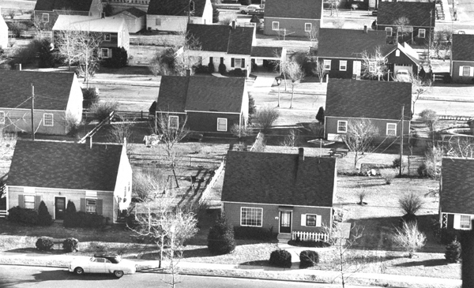In 1941, Bill and Alfred Levitt won a government contract to build thousands of homes for war workers in Norfolk, Virginia. At first, everything went wrong. Skilled workers were in short supply. The schedule was too tight. It looked like they would miss their deadlines and lose money. The Levitts decided to rethink how they built homes. They broke the construction process into 27 steps. Then they hired and trained 27 teams of workers, each of which specialized in just one step. By the time the project ended, they had revolutionized the process of building homes.

**Middle-Class Families Move to the Suburbs**

No industry had suffered more during the Depression and war years than the homebuilding industry. Housing starts had dropped from more than 1 million new homes a year to fewer than 100,000. By war’s end, housing was in such short supply that 250 used trolley cars were sold as homes in Chicago. Returning veterans were eager to buy homes and start families. The GI Bill was ready to assist them with home loans at low interest rates. But there were few homes to buy.

The Levitt brothers knew exactly how to help those veterans use those loans. In 1947, they began work on **Levittown** the first planned community in the nation. It was located on Long Island, about 20 miles from New York City. By 1951, the brothers had built 17,447 homes around Levittown. They would go on to build two more Levittowns, in Pennsylvania and New Jersey, by 1960.

To keep costs down, the Levitts built small, boxy, almost identical homes with two bedrooms and one bathroom. Different work crews moved from house to house doing only one job. There were tile crews and floor crews. One team specialized in white paint while another one only applied red paint. By mass-producing their homes in this way, the Levitts greatly sped up production. By 1948, the Levitts were building 36 houses a day. They also kept their prices under $8,000.

The first Levittown in New York was a kind of suburb called a bedroom community. Most people who lived there commuted by car or public transportation to jobs in New York City. Although a commute could be tiring, countless young families jumped at the chance to live in a clean, safe, child-friendly suburb. Between 1950 and 1956, the number of Americans living in suburban communities increased by 46 percent.

As a group, these new suburbanites were overwhelmingly white and middle class. Many suburbs, including Levittown, did not sell to African Americans. Indeed, this homogeneity was part of the appeal of suburbs. “Everybody lives on the same side of the tracks,” observed the *Saturday Evening Post* in 1954. “They have no slums to fret about, no families of conspicuous wealth to envy, no traditional upper crust to whet and thwart their social aspirations [ambitions].”

**Weather and Wages Spur Migration to the Sunbelt**

Americans were not only on the move from cities to suburbs. They were also moving from the northern half of the country to the **Sunbelt.** This “belt” of warm-weather states stretched across the southern third of the United States from Florida to California.

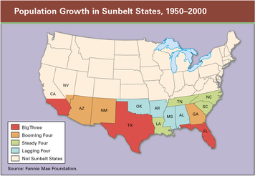After World War II, manufacturers and other businesses began locating in the Sunbelt. They were attracted by low labor costs. In addition, unions were less entrenched in the Sunbelt states than in the older industrial regions of the North. The Sunbelt tourist industry also grew, as families flocked to sunny beaches and new attractions like Disneyland.

As businesses moved south, people followed. California felt the effects of this migration as much as any state. Between 1950 and 1960, California’s population grew by 50 percent, from about 10.6 million to more than 15.7 million people. Other Sunbelt states experienced similar growth.

Two advances in technology made this large population shift possible. The first was the design and construction of massive water projects in the arid Southwest. These projects involved building dams on major rivers to capture precious water in huge reservoirs. This water was then distributed through a system of canals and aqueducts to fast-growing cities such as Phoenix, Arizona; Las Vegas, Nevada; and Los Angeles, California. The second key technology was the development of room air conditioners designed for home use. Air conditioning made summers bearable in Sunbelt states like Florida and Arizona. Annual sales of room air conditioners jumped from around 30,000 in 1946 to more than a million by 1953.

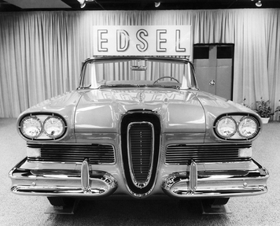On September 4, 1957, a new car called the Edsel appeared in Ford showrooms around the country. At first, consumers showed up at the dealerships in record numbers. Ford executives were thrilled. But then they realized people were looking, not buying. And most people did not like what they saw. The Edsel had been designed to be the biggest, flashiest, most luxurious Ford ever. Public response, however, was not enthusiastic. “One member of the media called it ‘an Oldsmobile sucking a lemon,’” recalls a rare Edsel owner, “and another called it ‘a Pontiac pushing a toilet seat.’” After three years of poor sales, Ford gave up on the Edsel. But such failures were rare in the 1950s. For most of the decade, automobile sales stayed strong as the growth of suburbs increased the demand for cars.

**The Middle-Class Dream: Two Cars in Every Garage**

Life in the suburbs depended on access to an automobile. Because most suburbs lacked public transportation, fathers commuted by car to their jobs in nearby cities. Mothers needed cars to drive to supermarkets and suburban shopping centers. After school, children depended on the family car to get to their music lessons or sports games. Suburban families began to find they needed not just one, but two cars in their garage.

Yet cars were more than a necessity in this booming consumer culture. They became a **status symbol** or sign of wealth and prestige. Automakers encouraged car owners to trade in last year’s models for new ones to keep up with their neighbors. Buyers were also urged to “move up” to ever-more-expensive cars to show that they had become a success in life. The Edsel was introduced as “the smart car for the young executive or professional family on the way up.” A 1958 ad proclaimed, “They’ll know you’ve *arrived* when you drive up in an Edsel.” That same year an Oldsmobile ad gushed,

Obviously this is a car to attract attention. Its precedent-breaking beauty fully deserves all the applause owners are giving it. Men and women who have just recently moved up to a ’58 Oldsmobile from another make are the loudest in their praise . . . proudest of their new possessions.

Throughout the 1950s, car sales stayed mostly above 7 million a year. By 1958, more than 67 million cars were on the road. Close to 12 million families owned two or more cars. Two years later, the census reported that 65 percent of all working people drove cars to work.

### Roads to Everywhere: The Interstate Highway System

As the majority of Americans came to depend on cars for transportation, they demanded more and better roads. State and federal lawmakers responded by funding new highway construction programs. The most ambitious was a program authorized by Congress in 1956 to construct a nationwide **interstate highway system.** The goal of this system was to connect major cities around the country by a network of super highways.

President Eisenhower strongly supported federal funding of the interstate highway system. He remembered how useful the four-lane autobahns, or high-speed highways built by Germany in the 1930s, had been for moving troops during World War II. With the United States engaged in the Cold War, a system of superhighways was seen as an important aid to the nation’s defense. Both troops and weapons could be transported easily and quickly with such a network of high-speed highways in place.

By 1960, about 10,000 miles of interstate highway had been constructed. Today, the system has about 45,000 miles of highway, all built to the same high standards. Interstate highways are divided, with at least two lanes in either direction. Access is controlled by the use of on-ramps and off-ramps. The flow of traffic is not interrupted by traffic lights or railroad crossings. Curves are engineered to be safe at high speeds. Rest areas are spaced along the way for the comfort of travelers.

The interstate highway system benefited the country in many ways. It made travel by road over long distances both faster and safer. It created economic opportunities as new roadside businesses, such as gas stations, motels, and restaurants, sprang up at interstate exits. By improving access to all parts of the country, the system gave people more choices as to where to live, work, shop, and vacation. For better or worse, the highways also increased Americans’ dependence on cars and trucks as their main form of transportation.

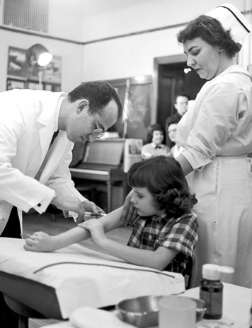In 1953, Charles Mee was a 14-year-old high school football player in Barrington, Illinois. One summer night, on the way to a dance, Mee fell ill. He was dizzy, unsteady on his feet, and chilled. Later that night, he could not stand up. His parents drove him to the nearest hospital. The head nurse took one look at Mee and pronounced, “This boy has polio.” Mee knew that his life was changed forever.

**Advances in Medicine Extend Life Expectancy**

It would have been small comfort to Mee to know that he was not alone. Polio, or infantile paralysis, was one of the most feared diseases of the 20th century. The first polio epidemic in the United States, in 1916, left 27,000 people paralyzed and 9,000 dead. Over the next 40 years, polio epidemics struck every summer across the country. The worst year was 1952, when almost 60,000 new polio cases were reported.

President Franklin Roosevelt was perhaps the most famous victim of polio. In 1938, he established the National Foundation for Infantile Paralysis to seek a cure for polio. Over the next 17 years, the foundation funded research to create a vaccine against polio. That research led to the development of the first **polio vaccine** by Dr. Jonas Salk. The vaccine was made up of very small parts of the polio virus. People who took the vaccine developed antibodies that protected them from infection by the actual polio virus. In 1954, some 2 million schoolchildren took part in trials of the vaccine. Statistics showed the vaccine to be as much as 90 percent effective in preventing polio. A dreaded disease had finally been conquered.

Surgical techniques advanced rapidly in the 1950s as well. The first open-heart surgery and the first kidney transplant were performed. The first pacemaker, a device designed to regulate the beating of a patient’s heart, was developed. Medical researchers also began to experiment with heart transplants.

A number of diseases once viewed as killers were routinely cured in the 1950s through the use of antibiotic drugs. Penicillin, streptomycin, and other “wonder drugs” attacked bacteria that caused everything from earaches to pneumonia and tuberculosis. These advances in medicine contributed to a rise in **life expectancy** during the 1950s. A child born in 1950 could expect to live to the age of 68. By 1960, the average life expectancy had reached 69.7 years.

**Peaceful Uses for Nuclear Energy**

During the 1950s, scientists explored peaceful uses for nuclear energy. One of the most promising was the generation of electricity. “It is not too much to expect that our children will enjoy in their homes electrical energy too cheap to meter,” predicted Lewis Strauss, chair of the U.S. Atomic Energy Commission, in 1954. Three years later, the first full-scale nuclear power plant opened in Shippingport, Pennsylvania.

Medical researchers were also finding new uses for nuclear energy. Radioactive isotopes were used in the diagnosis and treatment of disease. The use of X-rays as a diagnostic tool became a general practice in the 1950s. At the same time, specialists in nuclear medicine began to use radioactive iodine to treat thyroid cancer.

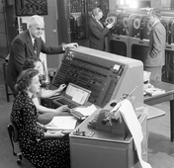**Computers Enter the Workplace**

In 1946, two engineers from the University of Pennsylvania built one of the earliest electronic digital computers. Called ENIAC (Electronic Numerical Integrator and Computer), it contained nearly 18,000 vacuum tubes and took up about 1,500 square feet of floor space—almost as much as two Levittown homes. It could perform 300 multiplications per second. Five years later, the same team introduced the first commercially successful computer. Called the UNIVAC, it could do more than just crunch numbers. The UNIVAC could handle letters and words. In 1952, a UNIVAC proved its power by accurately predicting the election of Eisenhower just 45 minutes after the polls closed.

The invention of the transistor in 1947 led to dramatic improvements in computer design. A transistor is a small, low-powered electronic device. By 1959, transistors had replaced the bulky and unreliable vacuum tubes. As computers shrank in size, they began to appear in more and more workplaces. The new machines revolutionized the collection and storage of data. They sped up the work of record keepers, such as librarians and tax collectors. But as the decade ended, few people could foresee a time when there would be a personal computer on almost every desk.