**Field Site 1: Problems in Cities and Workplaces – Background Information.**

While many Americans enjoyed the benefits of urban life in 1900, cities and city dwellers also suffered from serious problems. Many urban residents lived in poverty and labored under backbreaking conditions. They may have been tempted by the many goods generated by mass production, but most could not afford them. Even those who did have the money had no guarantee that the products were safe or reliable. Through their writings, muckrakers like Jacob Riis sought to expose these and other problems of urban life.

**Conditions in the Slums**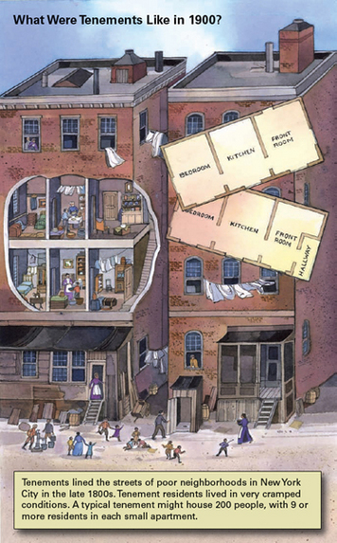

Many of the urban poor lived in slum tenements. They were crammed together in shoddy apartment buildings that housed four families on each floor. Each family had a very small living space. In Jacob Riis's book, a typical tenement is described as "one or two dark closets, used as bedrooms, with a living room twelve feet by ten."

Not only was each tenement crowded, but the buildings themselves were packed together. Some slum neighborhoods were among the most densely populated areas in the world. New York's Lower East Side, for example, housed 450,000 people in 1900. That amounted to more than 300,000 people per square mile. In contrast, New York City as a whole housed around 90,000 people per square mile.

One reason for poor living conditions in cities like New York was that the urban **infrastructure [infrastructure: the facilities or equipment required for an organization or community to function, including roads, sewage and power systems, and transportation]** was inadequate for such a large population. Infrastructure refers to the facilities and equipment required for an organization or community to function. It includes roads, sewage and power systems, and transportation. A number of muckrakers blamed city governments for failing to provide adequate infrastructure and services.

Lack of fire protection was one serious problem. At the turn of the century, many city roads and sidewalks were constructed of wood, making cities virtual firetraps. One historian described American cities of the day as "long lines of well-laid kindling." Much of Chicago burned to the ground in 1871, and much of San Francisco burned after the 1906 earthquake.

Cities also suffered from sanitation problems. By 1900, many middle-class homes had running water and indoor plumbing. These amenities reduced the incidence of disease in some neighborhoods, but they increased the amount of wastewater that cities had to remove. City engineers developed sewer systems to do the job. In poorer neighborhoods that lacked indoor plumbing, however, the waste often ended up on the streets. As a result of poor sanitation, contagious diseases such as tuberculosis and pneumonia often spread quickly through crowded slums.

**Problems in the Workplace**

Muckrakers also exposed terrible working conditions. By 1900, unskilled factory work had replaced most skilled manufacturing jobs. Many factory workers found their work boring and strenuous. One worker said, "Life in a factory is perhaps, with the exception of prison life, the most monotonous life a human being can live."

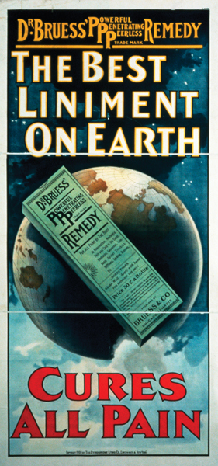

Factory work was also dangerous. Sharp blades threatened meatpackers. Cotton dust plagued textile workers. And fire posed a risk to nearly everyone who worked in close quarters in factories. Injuries could put workers out of jobs and throw their families into dire poverty.

Other workers, especially in the garment industry, worked at home for companies that paid them for each piece of work they completed. Many employers squeezed their workers by reducing the rate they paid per piece. Workers then had to work harder and faster to earn the same amount. It was common among immigrants for entire families, including children, to do piecework so that the family could make enough money to survive.

**Unsafe Products: Buyer Beware**

Increased production meant that more products were available, but buying them was not always a good idea. Consumers often did not know what was in the products because the government did not regulate product quality.

Meat was one example. In his 1906 novel ***The Jungle* [The Jungle: Upton Sinclair's 1906 novel about unsanitary conditions in meatpacking plants]** , muckraker Upton Sinclair wrote about unsanitary conditions in meatpacking plants: "There would be meat stored in great piles in rooms; and the water from leaky roofs would drip over it, and thousands of rats would race about on it." Sinclair reported that rat droppings, and even the rats themselves, often become part of processed meat. Canned goods were not regulated either. Toxic chemical preservatives like borax and formaldehyde contaminated many processed foods.

Many common medicines, like cough syrup, were also unregulated. Some products made ridiculous claims for curing illnesses, with the "cures" often involving narcotics. Medicine labels boasted such ingredients as morphine, opium, and cocaine. These substances were not prohibited, but their risks were becoming more apparent. Popular magazines told stories of consumers who believed that these medicines would cure their illnesses, only to fall prey to drug addiction.

Meanwhile, the growth of big businesses went largely unregulated, as monopolies took over many industries. Many Americans worried that small companies were being driven out of business and that monopolies were stifling opportunity. Muckrakers protested that big businesses were growing richer, while small businesses and the poor struggled even harder to survive.

**Field Site 2: Problems in the Environment - Background Information**.

By the turn of the century, urbanization and industrialization were transforming not only American society but also the natural environment. Alexis de Tocqueville, a Frenchman who had visited the United States in 1831, noted that Americans seemed to think nothing of remaking nature for the sake of progress. He observed that in the process of building towns, they could destroy forests, lakes, and rivers and "not see anything astonishing in all this. This incredible destruction, this even more surprising growth, seems to [them] the usual process of things in this world." By 1900, Americans had settled much of the country and exploited many of its natural resources. Doing so enabled tremendous economic growth, but it also came at a cost to the environment.

**Changing the Landscape**

As the 20th century began, economic activities had significantly changed the landscape. Forests were one example. Farmers cleared trees to plant crops, and loggers cut down large areas of woodland. The government encouraged logging by selling large plots of land in the Northwest for the lumber they could provide. By 1900, only a fraction of the country's virgin, or original, forests were still standing.

Ranching also transformed the landscape. Before settlers moved onto the Great Plains, buffalo had roamed across the region and grazed on its abundant grasslands. By the time the buffalo returned to places they had grazed before, the grass had grown back. But the cattle and sheep brought in by ranchers grazed the same area over and over, without moving on. As a result, they stripped the land of its natural vegetation and left it more vulnerable to erosion.

**Extracting Natural Resources**

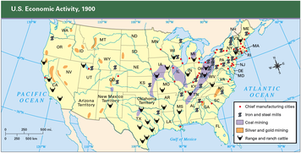The landscape was also transformed by **extractive industries [extractive industries: businesses that take mineral resources from the earth]** , businesses that take mineral resources from the earth. By 1900, mining companies were using explosives and drilling equipment to extract silver, copper, gold, iron, coal, and other minerals. Meanwhile, oil companies drilled deep to pump petroleum out of the ground.

Coal and other minerals were required to fuel industry. Factories burned coal to heat water to make the steam that powered machinery. The country was particularly rich in coal. Between 1860 and 1884, the amount of coal mined per year increased from 14 million tons to 100 million tons.

Mining was dangerous and also harmed the environment. Workers risked being buried alive if a mine caved in, and many got black-lung disease from breathing coal dust day after day. Mining scarred the land, leaving open shafts, slag heaps, and polluted streams behind. Unlike today, the government imposed no environmental regulations on mining companies.

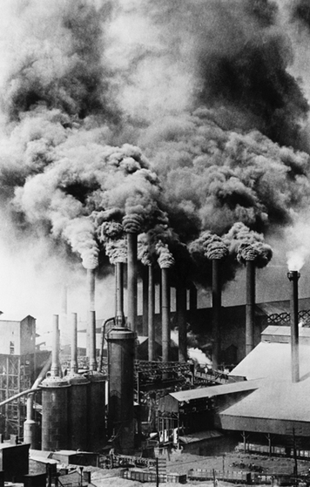Oil drilling also took its toll on the land. The first commercial oil wells were drilled in Pennsylvania. By 1900, oil extraction was underway in Texas and California as well. But finding oil was difficult. Developers often drilled deep in search of black gold, only to come away empty-handed. Whether successful or not, they left the earth torn behind them.

One historian explained that most Americans in the 1800s believed that "the river was waiting to be dammed . . . the prairie was waiting to be farmed, the woodlands to be cut down, and the desert to be irrigated." In other words, most people saw no problem with exploiting the environment and took no notice of the harm being done to the natural landscape.

**Polluting Water and Air**

Economic activities were also polluting the air and water in urban areas. In some cities, factories belched so much black smoke that it was difficult for people to breathe. In 1881, angry residents of New York City reported that the air smelled like sulfur, ammonia, kerosene, acid fumes, and phosphate fertilizer.

Pittsburgh, a steelmaking city, was known for being particularly filthy. The air was so polluted that it soiled everything. The people who lived closest to the steel plants suffered the worst of the pollution, but it affected those living outside the industrial center as well. One historian has written, "People's hands and faces were constantly grimy, clean collars quickly acquired a thin layer of soot, and the . . . coal dust gave clothes hung out in the weekly wash a permanent yellow tinge."

Another pollutant came from animals that lived in cities. Horses pulled carriages, and pigs roamed the streets eating garbage. Animal waste was often left where it landed, producing a foul stench and a serious disposal problem. According to one estimate, the 15,000 horses in Rochester, New York, left enough waste in a year to cover an acre of land with a layer 175 feet high.

City water was also polluted. In some cities, household sewage and industrial pollutants were simply released into nearby water sources without regard for the consequences. Other cities did try to avoid contaminating their drinking water. In Chicago, for example, engineers reversed the flow of the Chicago River so that sewage and factory waste would not flow into Lake Michigan. Some cities developed reservoirs to keep drinking water separate from wastewater. In some cases, rivers that were in the way or became too much of a health hazard were simply paved over.

**Field Site 3: Problems in Politics – Background Information**

Another problem at the turn of the century was political corruption. In 1902, the muckraking journalist Lincoln Steffens published *The Shame of the Cities*, a book on corruption in city government. The book exposed the rampant fraud that plagued cities throughout the nation. Steffens reported that politicians spoke openly about accepting bribes. "I make no pretensions to virtue," one politician said, "not even on Sunday."

Corruption served the interests of dishonest politicians and those who bribed them, while weakening the political influence of average Americans. In short, it distorted and undermined democracy.

**Political Machines and Bosses**

By 1900, many cities were controlled by **political machines [political machines: an organization consisting of full-time politicians whose main goal was to retain political power and the money and influence that went with it]** . These organizations consisted of full-time politicians whose main goal was to get and keep political power and the money and influence that went with it. Machines were usually associated with a political party. Party politicians joined forces to limit competition, while increasing their own power and wealth. At the top of this corrupt structure was the political boss, who controlled the machine and its politicians. Perhaps the most infamous of these bosses was William "Boss" Tweed of New York's **Tammany Hall [Tammany Hall: a political machine in New York City]** machine, who in the early 1870s cheated the city out of as much as $200 million.

Political machines exercised control at all levels of city government, down to the wards and precincts that subdivided most cities. Ward bosses and precinct captains got to know local residents and offered them assistance in exchange for political support. They helped immigrants who were sick or out of work. As one New York City ward boss said, "I never ask a hungry man about his past; I feed him, not because he is good, but because he needs food." This aid could take a wide variety of forms, including supplying a Christmas turkey or helping a grieving family by paying for a funeral. In exchange, residents agreed to vote for machine politicians at election time.

In some ways, the political machines worked for the good of city dwellers, particularly immigrants. At a time when the national and state governments did not provide such benefits as welfare for unemployed workers, local political machines filled the void.

**Corruption in Local and State Politics**

Although political machines provided aid, they also stifled opportunity for many citizens. Political bosses controlled access to city jobs, such as employment in the police and fire departments or on construction projects. With a good word from a boss, a poorly qualified person could land a job in place of a capable applicant.

The political machine also controlled business opportunities. To get a city work contract, a company often had to donate to the machine's reelection campaign. Many businesses also paid politicians to keep the city government from interfering with their activities. Such payoffs became part of the cost of doing business. Muckrakers called them bribery.

The political machines profited from urban entertainment, both legal and illegal. In exchange for a payoff, the boss could clear the way for such illegal activities as gambling. Even legal businesses such as baseball teams and vaudeville theaters paid the machine. Some political bosses saw these payments as informal taxes. They used some of the revenue to help those in need, but they made sure they profited themselves.

To keep control, political machines rigged local elections. Average citizens had little influence in choosing candidates, and the machine frequently used fraud to win at the polls. Candidates might pay citizens for their votes or stuff the ballot box with phony votes. By controlling elections, political machines maintained their grip on American cities.

At the state level, corrupt politicians tied to powerful industries, such as railroads and mining, controlled many state governments. In passing legislation that favored big business, state legislatures and governors often ignored the needs of average citizens.

**Corruption on the National Level**

The national government also suffered from corruption. For example, the Constitution gave state legislatures the power to choose senators, but corporations often bribed state legislators to elect their favored candidates to the Senate. The Senate became known as the Millionaires Club because many of its members were wealthy men with close ties to powerful industries.

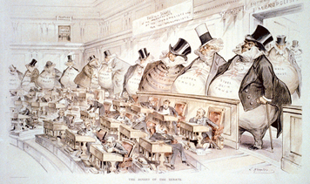

In both the House and the Senate, politicians received campaign contributions from big business in exchange for passing favorable legislation. The railroad monopolies, for example, frequently gave company stock to members of Congress who passed laws that strengthened the railroads. Other businesses also gave money to lawmakers who worked to limit competition.

Politicians frequently engaged in **patronage [patronage: the practice of politicians giving jobs to friends and supporters]** —giving jobs to friends and supporters. Some of these jobs went to unqualified people. In 1883, Congress passed the Pendleton Civil Service Reform Act to limit patronage. The **Pendleton Act [Pendleton Act: an 1883 federal law that limited patronage by creating a civil service commission to administer exams for certain nonmilitary government jobs]** set guidelines for hiring **civil service [civil service: nonmilitary government employees]** employees—nonmilitary government workers. It set up a civil service commission to administer exams to new applicants for government jobs. The jobs covered by this test had to be specified by the president. Over the years, most presidents have agreed to expand the number of specified jobs. Most civil service jobs are now based on merit.

**Field Site 4: Problems in Society – Background Information**

American cities in 1900 brought together many types of people in crowded and often difficult circumstances. As a result, social tensions increased. Many poor city dwellers resented the comfortable lives of the rich, while the rich often looked down on the poor as the source of urban problems. Many African Americans faced racism and violence as they struggled to improve their lives and claim their democratic rights. Women were also demanding greater opportunities and rights. Meanwhile, many American families feared that the stresses and strains of urban life were eroding traditional values.

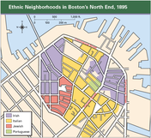**Growing Differences Between Social Classes**

During the late 1800s, the gap between rich and poor grew wider. Between 1865 and 1900, a small percentage of Americans grew fabulously wealthy. By 1891, according to one estimate, there were 120 Americans who were worth at least $10 million, an enormous sum at the time.

At the same time, the arrival of many immigrants swelled the ranks of the working class. Many workers found it nearly impossible to get ahead. Although wages increased gradually, the cost of living rose faster. So while the rich got richer, the poor continued to live in harsh circumstances. Many took lodgers into their tiny flats to help share the cost of rent.

Between the two extremes, the middle class expanded as a result of the rising productivity of the American economy. The growing middle class included doctors, lawyers, ministers, small business owners, merchants, and mid-level company managers.

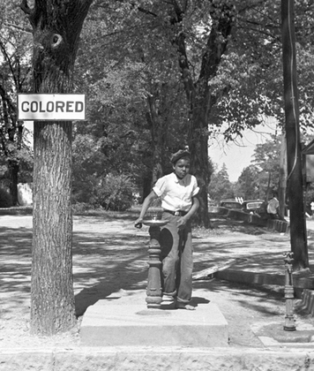By 1900, American cities were organized in ways that reflected class, race, and ethnic differences. The rich lived in mansions on streets like New York's elegant Fifth Avenue. Many Fifth Avenue residents also owned summer homes in places like Newport, Rhode Island. Their summer "cottages" were actually mansions resembling European palaces.

During this period, many middle-class families moved to comfortable homes in newly built suburbs. The men often commuted on streetcars, part of new urban transit systems. Members of the middle class tried to make their homes appear as elegant as the homes of the wealthy. Their houses often featured stained glass windows and fine furniture. Many also had reproductions of famous paintings hanging on their walls.

Working-class people remained in the cities. Immigrants tended to cluster together in ethnic neighborhoods, where they could maintain many of their old customs. Some immigrants, however, stayed in these areas because they were not allowed to live anywhere else. The Chinese in San Francisco were jammed together in one district known as Chinatown because they were barred from other areas. In cities like San Antonio and Los Angeles, Mexican immigrants lived in neighborhoods called *barrios*. African American migrants, too, generally lived in neighborhoods separated from other city residents.

**Life for African Americans**

In the 35 years since the end of the Civil War and the abolition of slavery, African Americans had made few gains in their struggle for equality. Many southern states had passed Jim Crow laws that segregated blacks from whites in trains, schools, hospitals, and other public places. Signs saying "White Only" and "Colored Only" told black Americans which waiting rooms they could enter, which bathrooms they could use, and where they could sit in theaters. Segregation affected nearly every aspect of public life in the South at the beginning of the 20th century.

In addition, by 1900 most African Americans in the South had been disenfranchised. Although the Fifteenth Amendment declared that voting rights could not be denied on the basis of "race, color, or previous condition of servitude," southern states found ways to bypass the law. Some state laws required potential voters to prove that they could read and write. These literacy tests often kept African American men from voting. So did poll taxes and property requirements. "Grandfather clauses" were another way to deny African American men the vote. Such clauses limited voting only to those men whose fathers or grandfathers had had the right to vote in 1867.

Violence against blacks was also common. Between 1882 and 1900, about 70 lynchings took place every year, mostly in the South. The victims were typically hanged or burned to death. In some cities, in both the North and the South, large-scale mob violence broke out against African Americans.

In response to racism, many African Americans fled from the South in the late 1800s. By 1900, more than 30 northern cities had 10,000 or more black residents. The number of black migrants from the South increased even more dramatically in the years that followed.

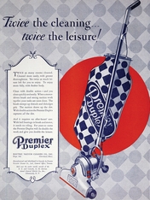**The Changing Role of Women**

Life for American women was changing, too. One trend was the growing number of women working outside the home. The number of women in the labor force nearly tripled between 1870 and 1900. At the start of the 20th century, women made up around 18 percent of the workforce. Many of these new workers were native-born, single white women. Some performed unskilled labor in textile, food-processing, and garment factories. Those with a high school education found skilled positions such as telephone operators, typists, department store clerks, nurses, and teachers. Meanwhile, many immigrant women did unskilled factory labor. Opportunities for African American women consisted mainly of working as domestic cooks or housekeepers.

New appliances made available through mass production changed the lives of many middle-class and upper-class women. Washing machines, gas stoves, carpet sweepers, and other conveniences made housework easier. For some women, however, these appliances also gave rise to new homemaking expectations. Gas stoves, for example, were far easier to use than wood stoves. But as they became available, cookbooks began to feature more time-consuming recipes. Nonetheless, the new appliances helped many women find more time for social causes and charitable activities outside the home.

Some women had the chance to attend college, too. A number of women's colleges, like Vassar, Wellesley, and Bryn Mawr, had opened after the Civil War. By 1890, nearly half of all American colleges accepted women. But the number of women in college was still fairly small compared with the number training for such occupations as teaching and nursing.

As the 20th century began, most American women did not have the right to vote. Although a few western states had granted voting rights to women, there was still no women's suffrage at the national level. Women known as suffragists actively pursued voting rights.

**Challenges for the American Family**

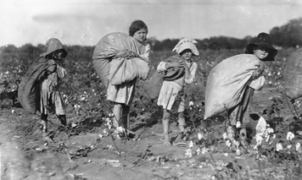The American family also faced challenges at the turn of the century, most notably around the issue of child labor. By 1900, roughly one out of every five children between the ages of 10 and 15 was a wage worker. About 1.7 million children toiled in factories, sweatshops, and mines or worked in other nonfarm jobs such as shining shoes and selling newspapers. "Breaker boys" in coal mines often worked 14 to 16 hours a day separating slate rock from coal. Grueling workweeks could stretch to 72 hours, leaving child workers little time for anything else.

Lack of education was another problem. Although public education expanded in the late 1800s, working for wages kept many children out of school. By and large, African Americans had even fewer educational opportunities than whites. In the segregated South, schools for blacks were often of inferior quality. Some African Americans, however, gained useful vocational training at all-black colleges such as Alabama's Tuskegee Institute.

Many people saw alcohol as another obstacle to improving family life and society as a whole. Since the early 1800s, there had been calls for temperance, or moderation in drinking habits. By the late 1800s, the **temperance movement [temperance movement: a reform movement calling for moderation in drinking alcohol]** had grown significantly. While some reformers emphasized moderation in drinking, a growing number wanted to ban alcohol altogether. Men who did not drink, they argued, were more likely to keep their jobs and to work hard to support their families. Many reformers believed that making alcohol illegal would help lift poor families out of poverty and improve social conditions in the cities.

In addition, many parents worried that city life was corrupting the morals of their children. They believed that urban entertainments such as vaudeville theaters, dance halls, and amusement parks contributed to immoral behavior by bringing young people together in questionable surroundings, unsupervised by adults. Many parents hoped that strong bonds within families and neighborhoods might protect children from the temptations of city life.

**Field Site 1: Problems in Cities and Workplaces – Primary Source Documents**

Slum Life

Enough of them [tenements] everywhere. Suppose we look into one? . . . Be a

little careful, please! The hall is dark and you might stumble over the children

pitching pennies back there. Not that it would hurt them; kicks and cuffs are their

daily diet. They have little else. Here where the hall turns and dives into utter darkness

is a step, and another, another. A flight of stairs. You can feel your way, if

you cannot see it. Close? Yes! What would you have? All the fresh air that ever

enters these stairs comes from the hall-door that is forever slamming, and from the

windows of dark bedrooms . . . That was a woman filling her pail by the hydrant

you just bumped against. The sinks are in the hallway, that all the tenants may

have access . . . In summer, when a thousand thirsty throats pant for a cooling

drink in this block, it is worked in vain . . . Here is a door. Listen! That short hacking

cough, that tiny, helpless wail—what do they mean? . . . Oh! a sadly familiar

story—before the day is at an end. The child is dying with measles. With half a

chance it might have lived; but it had none. That dark bedroom killed it.

—Jacob A. Riis, *How the Other Half Lives:*

*Studies Among the Tenements of New York,* 1890

The Workplace

The management assured me that no lead was used in the coatings and invited me

to inspect the workroom, where I found six Polish painters applying an enamel

paint to metal bathtubs . . . I [later] learned that the air is thick with enamel dust

and that this may be rich in red oxide of lead . . .

Lead is the oldest of the industrial poisons except carbon monoxide . . . It is a

poison which can act in many different ways, some of them so unusual and outside

the experience of the ordinary physician that he fails to recognize the cause . . .

A young Italian, who spoke no English, worked for a month in a white-lead plant

but without any idea that the harmless looking stuff was poisonous. There was a

great deal of dust in his work. One day he was seized with an agonizing pain in

his head which came on him so suddenly that he fell to the ground. He was sent to

the hospital, semiconscious, with convulsive attacks, and was there for two weeks;

when he came home, he had a relapse and had to go back to the hospital. Three

months later he was still in poor health and could not do a full day’s work.

—Alice Hamilton, *The Poisonous Occupations in Illinois: Physician Alice*

*Hamilton Explores the “Dangerous Trades” at the Turn of the Century,* 1943

Unsafe Products

And then there was “potted game” and “potted grouse,” “potted ham,” and

“devilled ham”—de-vyled, as the men called it. “De-vyled” ham was made out of

the waste ends of smoked beef that were too small to be sliced by the machines;

and also tripe, dyed with chemicals so that it would not show white; and trimmings

of hams and corned beef; and potatoes, skins and all; and finally the hard

cartilaginous gullets of beef, after the tongues had been cut out. All this ingenious

mixture was ground up and flavored with spices to make it taste like something.

—Upton Sinclair, *The Jungle,* 1906

**Field Site 2: Problems in the Environment – Primary Source Documents**

The Landscape

Many of nature’s five hundred kinds of wild trees had to make way for orchards

and cornfields. In the settlement and civilization of the country . . . the early settlers

. . . regarded God’s trees as only a larger kind of pernicious [harmful] weeds,

extremely hard to get rid of. Accordingly . . . trees in their beauty fell crashing by

millions, smashed to confusion, and the smoke of their burning has been rising

to heaven more than two hundred years. After the Atlantic coast from Maine

to Georgia had been mostly cleared and scorched into melancholy [depressed]

ruins, the overflowing multitude of bread and money seekers poured over the

Alleghanies into the fertile middle West, spreading ruthless devastation ever

wider and farther over the rich valley of the Mississippi and the vast shadowy

pine region about the Great Lakes. Thence still westward the invading horde of

destroyers called settlers made its fiery way over the broad Rocky Mountains, felling

and burning more fiercely than ever, until at last it has reached the wild side

of the continent, and entered the last of the great aboriginal forests on the shores

of the Pacific.

—John Muir, *American Forests,* 1897

Natural Resources

Laborers were dumping the coal into chutes. The huge lumps slid slowly on

their journey down through the building, from which they were to emerge in

classified [sorted] fragments. Great teeth on revolving cylinders caught them

and chewed them. At places there were grates that bid each size go into its

proper chute. The dust lay inches deep on every motionless thing, and clouds

of it made the air dark as from a violent tempest. A mighty gnashing sound filled

the ears. With terrible appetite this huge and hideous monster sat imperturbably

[steadily] munching coal, grinding its mammoth jaws with unearthly and monotonous

[repetitive] uproar.

—Stephen Crane, “In the Depths of a Coal Mine,”

McClure’s Magazine, August 1894

Pollution

One of the striking features of our neighborhood . . . was the presence of huge

wooden garbage boxes fastened to the street pavement in which the undisturbed

refuse [garbage] accumulated day by day. The system of garbage collecting was

inadequate throughout the city but it became the greatest menace in a ward such as

ours, where the normal amount of waste was much increased by the decayed fruit

and vegetables discarded by the . . . fruit peddlers, and by the residuum [residue]

left over from the piles of filthy rags which were fished out of the city dumps and

brought to the homes of the rag pickers for further sorting and washing.

—Jane Addams, *Twenty Years at Hull-House,* 1912

**Field Site 3: Problems in Politics– Primary Source Documents**

Political Machines and Bosses

And it is corruptible, this citizenship. “I know what Parks is doing,” said a New

York union workman, “but what do I care. He has raised my wages. Let him have

his graft!” And the Philadelphia merchant says the same thing: “The party leaders

may be getting more than they should out of the city, but that doesn’t hurt me.

It may raise taxes a little, but I can stand that. The party keeps up the protective

tariff. If that were cut down, my business would be ruined. So long as the party

stands pat [firmly] on that, I stand pat on the party.”

—Lincoln Steffens, *The Shame of the Cities,* 1904

Local and State Politics

The typical business man is a bad citizen; he is busy. If he is a “big business man”

and very busy, . . . he is busy with politics, oh, very busy and very businesslike. I

found him buying boodlers [frauds] in St. Louis, defending grafters in Minneapolis,

originating corruption in Pittsburgh, sharing with bosses in Philadelphia, deploring

reform in Chicago, and beating good government with corruption funds in New

York. He is a self-righteous fraud, this big business man. He is the chief source

of corruption . . .

The spirit of graft and of lawlessness is the American spirit.

—Lincoln Steffens, *The Shame of the Cities,* 1904

National Politics

The Senators are not elected by the people; they are elected by the “interests” . . .

The greatest single hold of “the interests” is the fact that they are the “campaign

contributors”—the men who supply the money for “keeping the party together,”

and for “getting out the vote.” Did you ever think where the millions for watchers,

spellbinders, halls, processions, posters, pamphlets, that are spent in national,

state and local campaigns come from? Who pays the big election expenses of

your congressman, of the men you send to the legislature to elect senators? Do

you imagine those who foot those huge bills are fools? Don’t you know that

they make sure of getting their money back, with interest . . . ?

—David Graham Phillips, “The Treason of the Senate,”

*Cosmopolitan,* March 1906

**Field Site 4: Problems in Society– Primary Source Documents**

Social Class

The world’s workers have always been and still are the world’s slaves. They

have borne all the burdens of the race and built all the monuments along the

track of civilization; they have produced all the world’s wealth and supported

all the world’s governments. They have conquered all things but their own

freedom. They are still the subject class in every nation on earth and the chief

function of every government is to keep them at the mercy of their masters . . .

They [workers] looked about them and saw a land of wonderful resources;

they saw the productive machinery made by their own hands and the vast

wealth produced by their own labor, in the shadow of which their wives and

children were perishing in the skeleton clutch of famine . . .

Poverty, high prices, unemployment, child slavery, widespread misery and

haggard [tired] want in a land bursting with abundance; prostitution and insanity,

suicide and crime, these in solemn numbers tell the tragic story.

—Eugene V. Debs, “Speech of Acceptance,”

*International Socialist Review,* October 1912

African Americans

For nearly twenty years lynching [hanging] crimes . . . have been committed and

permitted by this Christian nation. Nowhere in the civilized world save the United

States of America do men, possessing all civil and political power, go out in bands

of 50 and 5,000 to hunt down, shoot, hang or burn to death a single individual,

unarmed and absolutely powerless. Statistics show that nearly 10,000 American

citizens have been lynched in the past 20 years. To our appeals for justice the stereotyped

reply has been that the government could not interfere in a state matter

. . . We refuse to believe this country, so powerful to defend its citizens abroad,

is unable to protect its citizens at home. Italy and China have been indemnified

[condemned] by this government for the lynching of their citizens. We ask that

the government do as much for its own.

—Ida B. Wells-Barnett, petition to President William McKinley,

Women

To the man, the whole world was his world; his because he was male; and the

whole world of woman was the home; because she was female. She had her

prescribed sphere, strictly limited to her feminine occupations and interests; he

had all the rest of life; and not only so, but, having it, insisted on calling it male.

This accounts for the general attitude of men toward the now rapid humanization

of women. From her first faint struggles toward freedom and justice, to her present

valiant efforts toward full economic and political equality, each step has been

termed “unfeminine” and resented as an intrusion upon man’s place and power.

—Charlotte Perkins Gilman, *The Man-Made World:*

*Or, Our Androcentric Culture,* 1911*and Gazette,* April 9, 1898

**Field Investigation: Creating a Muckraking Notepad**

Create a muckraking notepad for your field investigation

by taking two sheets of paper from your notebook.

Cut each sheet into fourths to create eight equal-size

rectangles. Staple the rectangles together at the top to

make your notepad.

**K e y C o n t e n t m s**

Muckraking Notepad

As you complete the activity, use these

Key Content Terms in your notebook:

1. *The Jungle*
2. Extractive Industry
3. Tammany Hall
4. Pendleton Act
5. Temperance Movement
6. Muckraking

**Conduct Your Field Investigation**

When you reach a field site, open your muckraking

notepad to the first two pages. Divide the space into

three sections, and take notes by following the guidelines

below. When you move to the next field site, turn

to the next two pages. You must visit each field site at

least once and investigate a total of seven problems.

**Field Site: Topic:**

Examine the visual and written information

at the station. In this space, explain what

problem you think you have uncovered.

In this space, describe the problem using

vivid and shocking language that will stir

your reader into action. Write at least two

sentences about the photograph. Also choose

one sentence from the quotation to excerpt.

Read the corresponding section of Lesson

16. Then, in this space, record at least four

important pieces of information about the

problem.