ACADEMIC SCIENCE
Background Information: One of the most common misconceptions about evolution is seen in the statement that “humans came from apes.” This statement assumes that organisms evolve through a step-by-step progression from “lower” forms to “higher” forms of life and the direct transformation of one living species into another. Evolution, however, is not a progressive ladder. Furthermore, modern species are derived from, but are not the same as, organisms that lived in the past.

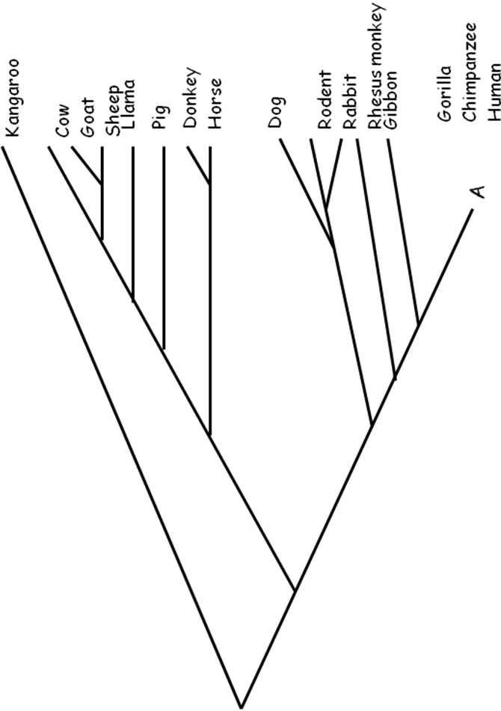
The theory of common descent, proposed by Charles Darwin, was revolutionary because it introduced the concept of gradual evolution based on natural mechanisms. The theory of common descent also replaced a model of straight-line evolution with that of a branching model based on a single origin of life and subsequent series of changes – branching – into different species.

Part I:

Look at the image to the right, and find the part of the morphological tree that shows the relationships between gorillas, chimpanzees, and humans. Notice that the lines connecting the common ancestor (A) to gorilla, chimpanzee, and human are missing.

Develop three hypotheses to explain how these organisms are related by drawing lines from Point A to each of the three organisms (G = gorilla, C = chimpanzee, H = human, A = common ancestor).
Hypothesis 1
G C H

A
Hypothesis 2
G C H

A
Hypothesis 3
G C H

A

- Which hypothesis do you think is the correct one? For your chosen hypothesis, explain what these lines are saying about the relationship between the three organisms (in other words, which species are more closely related?) ____________________________________________________________________

Part II

Modern research techniques allow biologists to compare the DNA that codes for certain proteins and to make predictions about the relatedness of the organisms from which they took the DNA. Biologists have determined that some mutations in DNA occur at a regular rate. They can use this rate as a “molecular clock” to predict when two organisms begin to separate from a common ancestor. You will use models of these techniques to test your hypotheses and determine which one is best supported by the data you develop.
Procedure:

- Each different color represents one of the four bases of DNA:
Blue = adenine (A) Green = guanine (G)
White = Thymine (T) Red = cytosine (C)

Work in groups of four; “synthesize” DNA strands using the colored pencils.

- Compare the human DNA to the chimpanzee by matching the strands base by base (square by square). Remember that DNA is complementary; this means that A matches with T and C matches with G when DNA forms.

- Count the number of bases that are not the same. Record the data in the table. Repeat these steps with the human DNA, the gorilla DNA, and the common ancestor DNA.

Part II Data:
 |  | DNA Sequence of Hemoglobin Protein
Human DNA
 | position 1 |  |  |  |  |  |  |  |  |  |  |  |  |  |  |  |  |  |  |  |  | 20
Chimpanzee cDNA
 | position 1 |  |  |  |  |  |  |  |  |  |  |  |  |  |  |  |  |  |  |  |  | 20
Gorilla cDNA
 | position 1 |  |  |  |  |  |  |  |  |  |  |  |  |  |  |  |  |  |  |  |  | 20
Common Ancestor cDNA
 | position 1 |  |  |  |  |  |  |  |  |  |  |  |  |  |  |  |  |  |  |  |  | 20
 |  |  | Adenine (A) |  |  |  |  | Thymine (T) |  |  |  |  | Guanine (G) |  |  |  |  | Cytosine ( C )
Data Table
Human DNA compared to: | Total # of unmatched bases | # of Sections of unmatched bases
Chimpanzee DNA
Gorilla DNA
Common Ancestor DNA
Part III: Biologists have determined that some mutations in DNA occur at a regular rate. They use this rate as a “molecular clock” to predict when 2 organisms began to separate from a common ancestor. Most evolutionary biologists agree that humans, gorillas, and chimpanzees shared a common ancestor at one point in their evolutionary history. They disagree, however, on specific relationships between these three species. Use data above to answer the questions and predict which hypothesis for their relationship is most valid.
- Which DNA is most similar to the common-ancestor DNA?

- What does this data suggest about the relationship between humans, gorillas, and chimpanzees? Explain how you determined your answer.
- What is causing the DNA to be different among the species of apes?

5. Does the data support any of your hypotheses? Why or why not?

6. Hypothetically, if scientists determine that on average, one mutation occurs in this hemoglobin DNA sequence every one million years, how many million years ago did humans and chimpanzees split from a common ancestor? When did the common ancestor between gorillas and humans exist? Explain how you came up with your answers.

7. According to all the data collected, which of the following statements is most accurate? Explain.
  - Chimpanzees and humans have a common ancestor.
  - Chimpanzees are the direct ancestors of humans.

- Suppose Paleontologists discover the fossil remains of the common ancestor and were able to sequence its DNA. If its hemoglobin sequence was more similar to the human and gorilla than the chimpanzee, how would the primate family tree change?

- If scientists have determined that on average one mutation occurs in hemoglobin DNA sequences every one million years, how many million years ago did humans and chimpanzees split from a common ancestor? Explain how you determined this.

HEMOGLOBIN GENE SEQUENCES
- Human DNA - Synthesize a strand of DNA that has the following sequence:
Position 1 Position 20
A-G-G-C-A-T-A-A-A-C-C-A-A-C-C-G-A-T-T-A

- Chimpanzee cDNA - Synthesize a strand of DNA that has the following sequence:
Position 1 Position 20
T-C-C-G-G-G-G-A-A-G-G-T-T-G-G-C-T-A-A-T

- Gorilla DNA - Synthesize a strand of DNA that has the following sequence:
Position 1 Position 20
T-C-C-G-G-G-G-A-A-G-G-T-T-G-G-T-C-C-G-G

- Common Ancestor DNA - Synthesize a strand of DNA that has the following sequence:
Position 1 Position 20
T-C-C-G-G-C-C-G-A-G-G-T-T-G-G-T-C-C-G-G
This strand represents a small section of the gene that codes for hemoglobin protein of a common ancestor of the gorilla, chimpanzee, and human. This model was constructed from hypothetical data, since no such DNA yet, exists for the common ancestor, but the other three sequences are real.

